# SEMINAR Library management system

**A major project submitted for the partial fulfilment of the requirements for the degree of**

***Bachelor of Computer Application***

Submitted By

Koulick Ghosh

Roll No: 15201220036 Session: 2020-2023



Techno India (Hooghly Campus)

Dharampur, Santiniketan, Near Khadinamore

G.T. Road, Chinsurah, Hooghly-712101

Phone: 033-2680-2389/6565

Website: [www.technoindiahooghly.org](http://www.technoindiahooghly.org/)  Email: info@technoindiahooghly.org

Certificate

This is to certify that the project entitled **“Seminar Library Management System”** submitted by **Koulick Ghosh** University Roll No: **15201220036** as Assigned Project (Major) partial fulfilment of degree of Bachelor of Computer Application have successfully completed her project and is worth of acceptance.

_____________________ __________________________

*Project Supervisor Head of the Department (BCA)*



# **ACKNOWLEDGEMENT**

It is our pleasure to be indebted to various people, who directly or indirectly contributed in the development of this work and who influenced our thinking, behaviour, and acts during the course of study.

We express sincere gratitude to our respected Principal sir for providing us an opportunity to undergo this project at **TECHNO INDIA (HOOGHLY CAMPUS)**.

We are also thankful to sir **Subhendu Saha** for their support, cooperation, and motivation provided to us during the training for constant inspiration, presence and blessings.

Lastly, we would like to thank the almighty and our parents for their moral support and our friends with whom we shared our day-to-day experience and received lots of suggestions that improved our quality of work.

Koulick Ghosh

CONTENTS

1. Introduction -------------------------------------------------------------------------- 7

2. Objective and Scope of the project ----------------------------------------------- 8

2.1 Objective --------------------------------------------------------------------- 8

2.2 Scope ------------------------------------------------------------------------- 9

3. Theoretical Background -----------------------------------------------------------10

1. Problem Definition ---------------------------------------------------------------- 11
2. System Analysis and Design via User requirements ------------------------- 12
3. Feasibility study --------------------------------------------------------------------------14
   1. Why is feasibility study ----------------------------------------------------------
   2. Technical, Economic, Operational, Social ------------------------------------
4. System Planning ------------------------------------------------------------------ 15
   1. Project cycle ----------------------------------------------------------------------- 15
   2. PERT Chart ----------------------------------------------------------------------- 16
   3. GRANT chart --------------------------------------------------------------------- 16
5. Software Requirement Specification ---------------------------------------17
   1. Functional & Non-Functional ----------------------------------------17
   2. Interface Requirement ------------------------------------------------ 18
   3. Tools in Development ------------------------------------------------ 19
6. Cost and Benefit Analysis -------------------------------------------------- 20

10. Software Design Specification ----------------------------------------------- 22

10.1 Entity Relationship Diagram ------------------------------------------------------ 22

10.2 Data Flow Diagram ----------------------------------------------------------------- 23

10.3 Sequence Diagram ------------------------------------------------------------------ 24

10.4 Use Case Diagram---------------------------------------------------------- 25

10.5 Database Schema ------------------------------------------------------------------- 26

1. Methodology used for testing and some testing results ------------------ 27

8.1 Test case 1 ---------------------------------------------------------------------- 27

8.2 Test case 2 --------------------------------------------------------------------- 28

8.3 Test case 3 --------------------------------------------------------------------- 28

8.4 Test case 4 --------------------------------------------------------------------- 29

8.5 Test case 5 --------------------------------------------------------------------- 29

1. User Manual ------------------------------------------------------------------ 30
   1. User -------------------------------------------------------------------------------- 30
   2. Admin ------------------------------------------------------------------------------ 37

12. Conclusion ------------------------------------------------------------------ 45

13. Bibliography ---------------------------------------------------------------- 46

### abstract

The Library Management System (LMS) project is a software solution designed to efficiently manage and organize library operations. It automates tasks such as cataloguing, lending, returning, and tracking of library resources while streamlining administrative processes. The project provides a user-friendly interface for staff and patrons, enabling easy access and utilization of library resources. It includes features like online catalo searching, material reservation, and personalized user accounts to enhance the user experience and promote self-service capabilities. The LMS project utilizes a centralized database to store comprehensive information about library resources, facilitating efficient searching and retrieval based on various criteria. It also includes functionalities for managing member records, automating reminders for overdue items and fines. The project benefits administrative staff through simplified inventory management, report generation, and circulation tracking. Integration with other systems enables seamless access to electronic resources and fosters library collaboration. Overall, the Library Management System project improves service quality, increases productivity, and optimizes resource management in libraries.

### Introduction

The Library Management System (LMS) project is a sophisticated software solution designed to revolutionize the way libraries operate and serve their patrons. In today's digital era, libraries face the challenge of efficiently managing their vast collections of resources while providing seamless access to information. The LMS project aims to address these challenges by automating and streamlining various library processes.

Traditionally, libraries have relied on manual cataloguing, book lending, and record-keeping systems. These manual processes are time-consuming, prone to errors, and hinder the overall efficiency of library operations. The LMS project offers a comprehensive solution by leveraging technology to automate key tasks, allowing librarians to focus on providing quality services to library users.

With the LMS, users can easily search and access library resources through an intuitive online catalo. They can browse through titles, authors, subjects, and even keywords to find the materials they need. Additionally, the system enables patrons to reserve items, track their borrowing history, and receive automated reminders for returning overdue materials.

For librarians and administrators, the LMS project simplifies the management of library resources. It provides a centralized database that stores comprehensive information about books, journals, multimedia materials, and more. This database facilitates efficient cataloguing, tracking, and inventory management, saving valuable time and resources.

Moreover, the LMS project offers features such as analytics and reporting capabilities, allowing administrators to gain insights into resource utilization, circulation patterns, and user preferences. These insights can inform collection development decisions and resource allocation strategies.

Overall, the Library Management System project aims to transform libraries into modern, efficient, and user-centric institutions. By embracing technology and automation, libraries can enhance the user experience, improve operational efficiency, and better serve the needs of their patrons in the digital age.

Objective and Scope of the Project

Objective:

The objective of the Library Management System (LMS) project is to develop a comprehensive software solution that automates and streamlines various library processes to enhance operational efficiency, improve user experience, and optimize resource management. The primary goals of the project include:

1. Automation: To automate manual tasks such as cataloguing, lending, returning, and tracking of library resources, reducing human error and improving accuracy and speed.

2. Accessibility: To provide patrons with easy access to library resources through an intuitive online catalo, enabling them to search, reserve, and borrow materials efficiently.

3. User Experience: To enhance the overall user experience by offering personalized user accounts, automated reminders for due dates and fines, and self-service capabilities.

4. Resource Management: To centralize and manage comprehensive information about library resources, including books, journals, multimedia items, and other materials, enabling efficient searching, sorting, and retrieval.

5. Administrative Efficiency: To simplify administrative tasks such as inventory management, report generation, and circulation tracking, enabling library staff to focus on providing quality services.

Scope:

The scope of the LMS project includes the following key aspects:

1. Cataloguing and Resource Management: Development of a centralized database to store and manage information about library resources, including titles, authors, subjects, and keywords, enabling efficient cataloguing and retrieval.

2. Patron Management: Implementation of functionalities to manage member records, including registration, membership renewal, and fee payment, as well as automated reminders for overdue items and fines.

3. Online Catalo and Reservation System: Design and development of an intuitive and user-friendly online catalo that allows patrons to search, reserve, and track materials, providing seamless access to library resources.

4. Administrative Tools: Integration of tools for inventory management, circulation tracking, and reporting, enabling library staff to efficiently manage resources, generate reports, and gain insights into usage patterns.

5. Integration and Collaboration: Support for integration with other systems, such as online library networks or digital repositories, to facilitate access to electronic resources and promote collaboration among libraries.

It is important to note that the project's scope may vary based on the specific requirements and resources available, and it may be expanded or customized to meet the unique needs of the library implementing the system.

THEORITICAL BACKGROUND

The theoretical background of a Library Management System (LMS) project incorporates several key concepts and principles from library science, information management, and technology. Here are some important theoretical foundations of an LMS project:

1. Library Science: Library Science provides the theoretical framework for organizing and managing library resources effectively. This includes principles of cataloguing, classification, and indexing of materials, as well as collection development strategies and information retrieval techniques. These principles help in designing the structure and functionality of the LMS to ensure efficient resource management and retrieval.

2. Information Management: Information management theories play a vital role in an LMS project. This involves the principles of organizing, storing, and retrieving information efficiently and accurately. The project incorporates concepts such as metadata standards, database management, and information architecture to ensure seamless access to library resources.

3. User Experience (UX) Design: UX design principles focus on creating user-friendly interfaces and enhancing the user experience. The LMS project takes into account theories of human-computer interaction, usability, and user-cantered design to develop intuitive interfaces that enable patrons to navigate the system easily, search for resources, and perform various tasks with minimal effort.

4. Systems Analysis and Design: The LMS project incorporates principles of systems analysis and design to understand the requirements of the library and its users. This involves gathering user needs, defining system functionalities, and designing workflows and processes to meet those needs effectively. The project also considers system architecture, data modelling, and software development methodologies to ensure a well-designed and scalable LMS.

5. Information Technology: Theoretical foundations in information technology underpin the technical aspects of the LMS project. This includes concepts such as database management systems, software development frameworks, network infrastructure, security protocols, and integration with other systems. These theoretical aspects ensure that the LMS project leverages appropriate technologies to provide a robust and secure system for managing library operations.

By incorporating these theoretical backgrounds, the LMS project aims to develop a comprehensive and efficient software solution that aligns with established principles and best practices in library science, information management, and technology.

Problem Definition

The Library Management System (LMS) project addresses several challenges faced by traditional libraries and their manual management processes. The following problem areas serve as the basis for the development of the LMS project:

1. Manual and Time-Consuming Processes: Traditional library operations heavily rely on manual processes for cataloguing, lending, returning, and tracking library resources. These processes are time-consuming, prone to errors, and require significant staff resources. The LMS project aims to automate these processes, reducing human error, improving efficiency, and freeing up staff time for other valuable tasks.

2. Inefficient Resource Management: Managing a large collection of diverse resources, such as books, journals, multimedia materials, and more, can be challenging without a centralized system. Traditional libraries often struggle with efficient cataloguing, tracking, and inventory management. The LMS project seeks to address these inefficiencies by providing a centralized database and automated resource management functionalities.

3. Limited Accessibility and User Experience: Traditional libraries may face limitations in terms of accessibility to resources and user experience. Users may have difficulty locating and accessing desired materials, leading to frustration and reduced utilization. The LMS project aims to enhance user accessibility by providing an intuitive online catalo, personalized user accounts, and streamlined borrowing and reservation processes.

4. Lack of Real-time Data and Analytics: Traditional libraries often lack real-time data and analytics regarding resource usage, circulation patterns, and user preferences. This can hinder decision-making processes related to collection development, resource allocation, and service improvements. The LMS project aims to provide data-driven insights and analytics, empowering library administrators to make informed decisions.

5. Integration and Collaboration Challenges: Libraries often face challenges in integrating with external systems, such as online library networks or digital repositories, hindering seamless access to electronic resources and collaboration among libraries. The LMS project seeks to facilitate integration with external systems, fostering collaboration and expanding the range of accessible resources.

By addressing these problem areas, the LMS project aims to overcome the limitations of traditional library management processes and improve operational efficiency, resource management, user experience, and collaboration within the library ecosystem.

System design and design via user requirements

System Analysis and Design via User Requirements for Library Management System Project:

System analysis and design play a crucial role in the development of a Library Management System (LMS) project. It involves understanding the needs and requirements of the users, both library staff and patrons, to design a system that fulfils their expectations. Here is a breakdown of the system analysis and design process based on user requirements for the LMS project:

1. Gathering User Requirements: Conduct interviews, surveys, and workshops with library staff and patrons to identify their needs and expectations from the LMS.

- Gather information about cataloguing requirements, resource management processes, circulation policies, and user services.

- Identify specific functionalities required, such as online catalo search, reservation system, member registration, and report generation.

2. Use Case Analysis: Identify key use cases based on user requirements, such as searching for resources, borrowing and returning materials, managing member records, and generating reports.

- Develop use case diagrams and scenarios to illustrate the interactions between users and the LMS system.

- Identify actors involved, such as library staff, patrons, and administrators, and define their roles and responsibilities.

3. Data Modelling: Identify the data entities required for the LMS system, such as books, patrons, transactions, and library resources.

- Design an Entity-Relationship Diagram (ERD) to visualize the relationships between different entities and define their attributes.

- Determine the data storage and retrieval requirements, considering scalability and performance.

4. System Design: Design the system architecture, including the client-server structure and network infrastructure.

- Define the software and hardware components required for the LMS system, ensuring compatibility and scalability.

5. User Interface Design: Design intuitive and user-friendly interfaces for different user roles, including staff and patrons.

- Create wireframes and prototypes to visualize the user interface and gather feedback from users.

- Ensure consistency, usability, and accessibility in the design to enhance the user experience.

6. System Testing: Develop a comprehensive testing plan to validate the functionalities of the LMS system.

- Perform unit testing, integration testing, and system testing to identify and resolve any issues or bugs.

- Conduct user acceptance testing to involve users in evaluating the system's compliance with their requirements.

7. System Deployment: Plan and execute the deployment process, including installation, configuration, and data migration.

- Provide training and documentation to library staff and users to ensure a smooth transition to the new system.

- Monitor the system after deployment and address any issues or performance concerns that arise.

By following a systematic approach to system analysis and design based on user requirements, the LMS project can create a robust, user-friendly, and efficient system that meets the needs of library staff and patrons, improving library operations and user experiences.

Feasibility study

**Why is feasibility study required?**

A feasibility study is essential in library management systems to determine the practicality and viability of implementing such a system. It helps assess factors such as cost, resources, time, and technical requirements. It ensures informed decision-making, identifies potential challenges, and provides a basis for planning and implementation, ultimately leading to an effective and successful library management system**.**

T**echnical feasibility study required in library management system.**

A technical feasibility study is necessary in a library management system to evaluate if the system can be implemented using the available technology infrastructure, considering factors such as hardware, software, network capabilities, and compatibility with existing systems.

**Economic feasibility study required in library management system.**

An economic feasibility study is necessary in a library management system to assess the financial viability and benefits of implementing the system, considering costs, and potential cost savings or revenue generation.

**Operational feasibility study required in library management system.**

An operational feasibility study is necessary in a library management system to determine if the system can be effectively integrated into the library's operations, considering factors such as staff capabilities, workflow, and user acceptance.

**Social feasibility study required in library management system.**

A social feasibility study is not a commonly emphasized aspect of a library management system. The system can help ensure that the system enhances social interactions, inclusivity, and overall user experience.

System Planning

**project life cycle:**

The project life cycle of an online library management system involves several stages. It begins with initiation, where the need for the system is identified. Planning follows, defining objectives, creating a project plan, and determining system requirements. Analysis involves gathering user requirements and designing the system architecture. Development encompasses building the system and its modules. Testing ensures functionality, performance, and user acceptance. Deployment involves installation and configuration, while operations and maintenance provide ongoing support, updates, and enhancements for the system's optimal functioning.

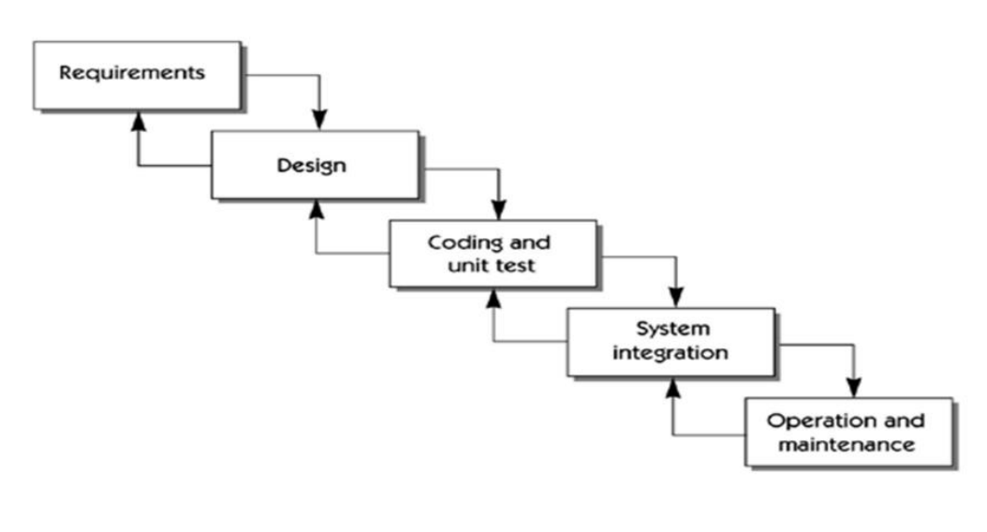

**GANTT chart:**

A Gantt chart is a visual representation that illustrates the project timeline, tasks, durations, dependencies, and milestones for an online library management system project, enabling effective project planning and tracking.

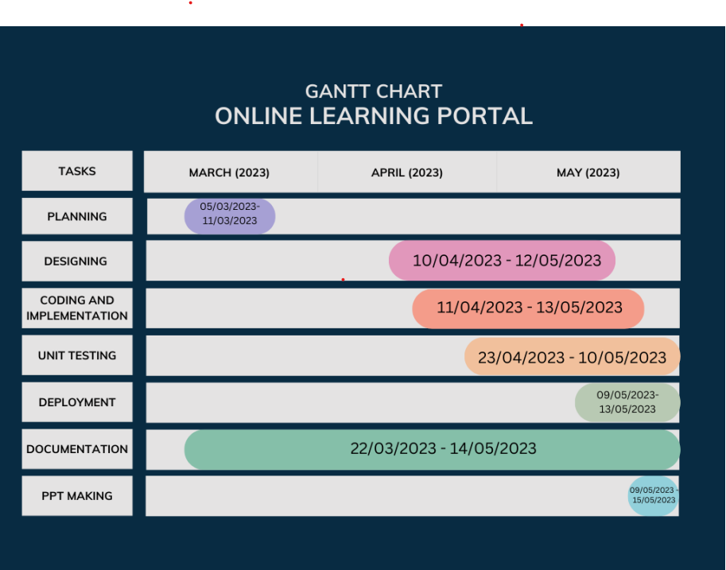

**PERT Chart:**

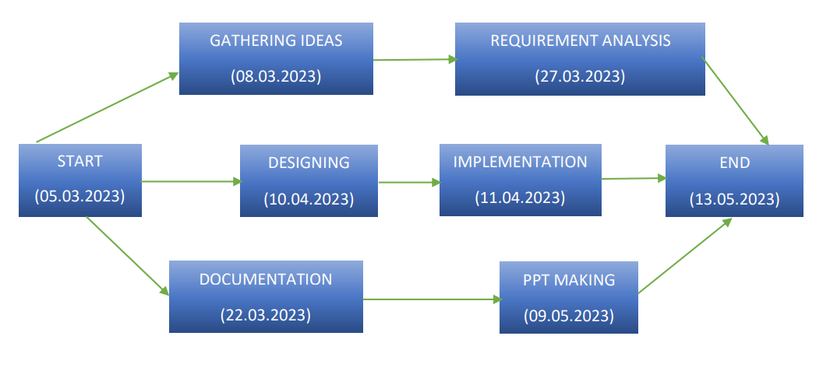A PERT (Program Evaluation and Review Technique) chart is a project management tool that depicts tasks, their dependencies, and estimated durations in a network diagram format, facilitating project scheduling, identifying critical path, and managing dependencies.

Software Requirement Specification

**Functional requirements:**

**improved Efficiency:** The system automates various library processes, reducing manual effort and saving time for librarians and users. It streamlines tasks like cataloguing, circulation, and inventory management, leading to increased operational efficiency.

**Enhanced User Experience:** Users can easily search for and access resources, place requests, and renew items through the online catalogue. The system provides personalized recommendations and notifications, improving the overall user experience.

**Accurate Resource Tracking:** With the system's tracking capabilities, librarians can accurately monitor the movement of library materials, reducing loss, misplacement, and theft. This ensures the availability of resources when needed.

**Effective Resource Utilization**: The system helps optimize resource allocation by providing insights into the usage patterns, popularity of resources, and user preferences. Libraries can make informed decisions regarding collection development and resource acquisition.

**Data Management and Analysis:** The system captures and stores valuable data on library operations, users, and resources. Librarians can analyse this data to gain insights, identify trends, and make informed decisions for improving library services and resource management.

**Non-functional requirements**

1. Performance: The system should be able to handle a large number of users and transactions simultaneously, ensuring fast response times and minimal downtime.

2. Scalability: The system should be easily scalable to accommodate future growth in the library's collection and user base.

3. Security: The system should have robust security measures in place to protect sensitive user information and prevent unauthorized access or data breaches.

4. Usability: The system should be intuitive and user-friendly, allowing both library staff and patrons to navigate and use the system with ease.

5. Reliability: The system should be highly reliable, minimizing errors and ensuring that critical operations are not disrupted.

6. Availability: The system should be available 24/7, with minimal scheduled downtime for maintenance and updates.

**INTERFACE REQUIREMENTS**

**Theoretical Background: -**

These requirements include user interfaces (interaction logic between software and user), screen layouts, buttons, functions on every screen, hardware interfaces (here a team describes what devices the software is created for), and other relevant particularities.

**Hardware Interfaces: -**

For running this website, we need: - Severe Requirement: - Computer with a minimum of 500 MB Hard disk, Processors after Pentium 3 and a minimum of 1 GB RAM. Client Requirement: Computer with an active internet connection of a minimum of 10kbps speed and a proper browser (preferably Google Chrome).

**Software Interfaces: -**

1. The Website needs to import/export data to databases using MySQL.

2. Operating System: - Windows 10 to higher, Linux,

3. The website must have data getting fetched from databases which can reduce the buffer time.

4. Proper validations is a must to reduce redundancy and duplication of data.

**User Interfaces: -**

1. The User Interface can be designed using HTML, CSS and JS and Bootstrap.

2. It should enable the users to login/register, go through the tutorials, have some program practice in IDE and test themselves.

3. The user interface should not be designed in a complex manner rather it should be designed in such a way that it is easily understandable and simple.

4. The buttons like the log out, login, register, etc. should be highlighted so that the user can find them rightly.

**Communication Interfaces: -**

1. Web Browser: - Google Chrome, Mozilla Firefox and Opera 3

2. Communication standards or protocols: - http, https or FTP

3. Electronic forms: - HTML forms that should be responsive using JS.

4. Contacting us using E-mails or using WhatsApp services. The data transfer rate for WhatsApp is that a user can send a file below 15 MB.

**Tools in Development**

**Dreamweave**r is a web development tool developed by Adobe that provides a visual interface for designing and coding websites. It offers features such as code highlighting, visual layout tools, and integration with other Adobe software. Dreamweaver supports multiple programming languages and frameworks, making it versatile for various web development projects.

**WampServe**r, on the other hand, is a software stack that includes Apache web server, MySQL database, and PHP scripting language, hence the name WAMP (Windows, Apache, MySQL, PHP). It provides a local development environment for creating dynamic web applications. WampServer simplifies the setup and configuration process, allowing developers to test and deploy web applications on their local machines before going live.

Cost and benefit analysis

When a project is developed costs are incurred through its lifecycle. Benefits are realized in the form of reduced operation costs, improved corporate image, staff efficiency or revenues.

Cost and benefit analysis is a procedure that gives a picture of the various costs, benefits & rules associated with a system. The determination of costs & benefits entails the following steps: -

1. Costs & benefits pertaining to the project are identified.

2. The various costs & benefits are categorized for analysis.

3. An evaluation method is selected.

4. The results of analysis are interpreted. Costs are identified as tangible, intangible costs, direct and indirect costs, fixed and variable costs.

COST ESTIMATION TECHNIQUE

There are three types of cost estimation techniques: -

1. Empirical Estimation

2. Heuristic Method

3. Analytic Method

The **Empirical Estimation** includes **Expert Judgement** technique and **Delphi Cost Estimation** technique.

The Heuristic Estimation may be single value or multi-variable method. One such example may be COCOMO technique (Constructive Cost Model).

The Analytic Estimation is used to measure work. A task is broken down into basic component operations or elements. If standard times are available from another source, these are applied to elements.

We’ll be using COCOMO model for cost estimation of our project. Boehm proposed COCOMO (Constructive Cost Estimation Model) in 1981.COCOMO is one of the most generally used software estimation models in the world. COCOMO predicts the efforts and schedule of a software product based on the size of the software.

COCOMO has three levels: -

• Basic COCOMO

• Intermediate COCOMO

• Advanced COCOMO

COCOMO is defined on three types of software:-

• Organic

• Semi-detached

• Advanced

We’ll be using Basic COCOMO of semi-detached type as our project satisfies semi-detached criterion.

**CALCULATION: -**

For basic COCOMO, we calculate the development effort as

**Effort = a*(KLOC)b**

And the time to develop as:-

**Tdev = c*(Effort)d**

The person required for project is:-

**Person = Effort/TdevB**

**\*\* KLOC= Kilo Lines of Code. For Cost estimation, we need to assume the volume of the project, i.e., the coding lines. This is known as LINES OF CODES(LOC). 1 KLOC= 1000 LOC.**

The values of a, b, c, d for Semi-detached type are: -

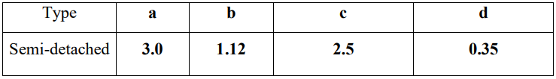

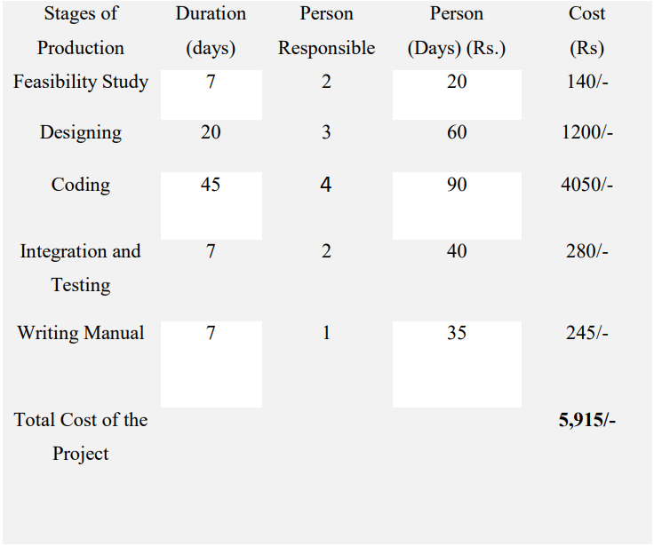

Software Design Specification

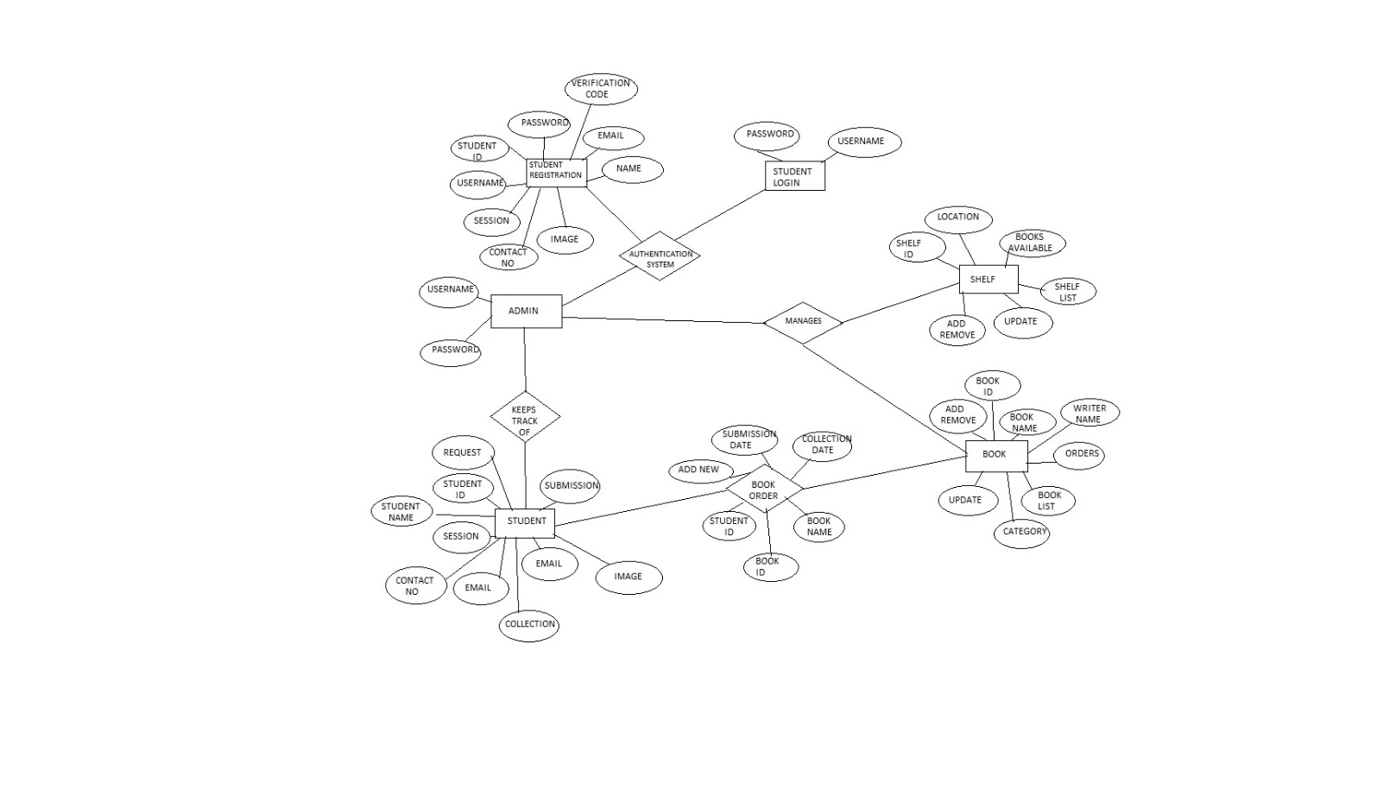**ER Diagram :-**

**Data Flow Diagram (user) :-**

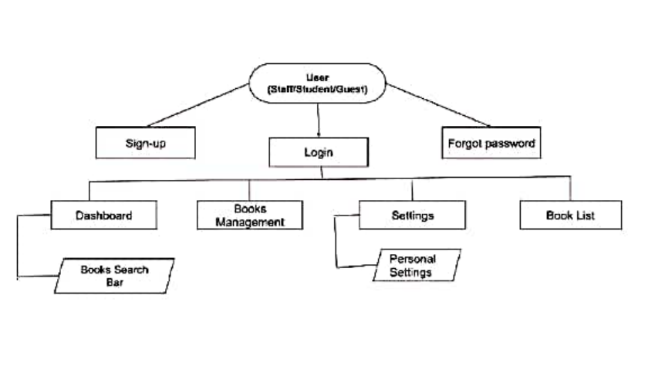

**Data Flow Diagram (admin) :-**

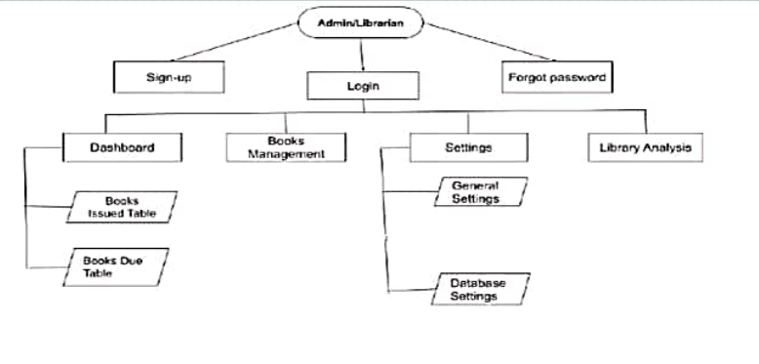

**Sequence Diagram :-**

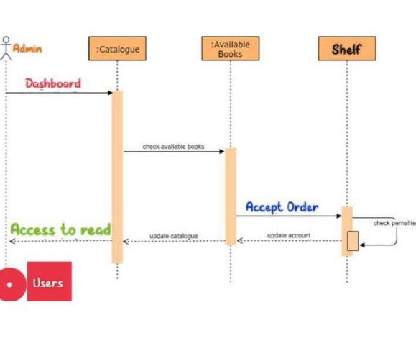

**Use case Diagram :-**

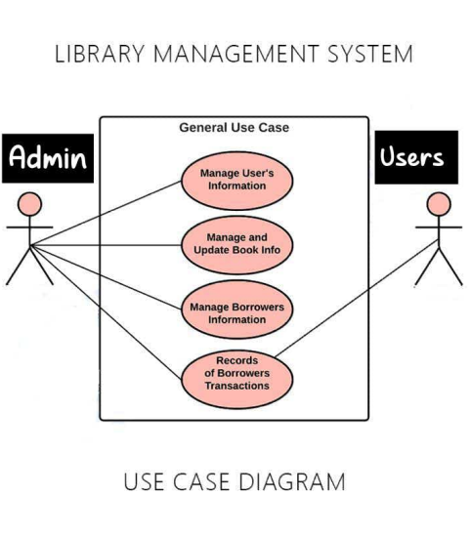

**Database Schema :-**

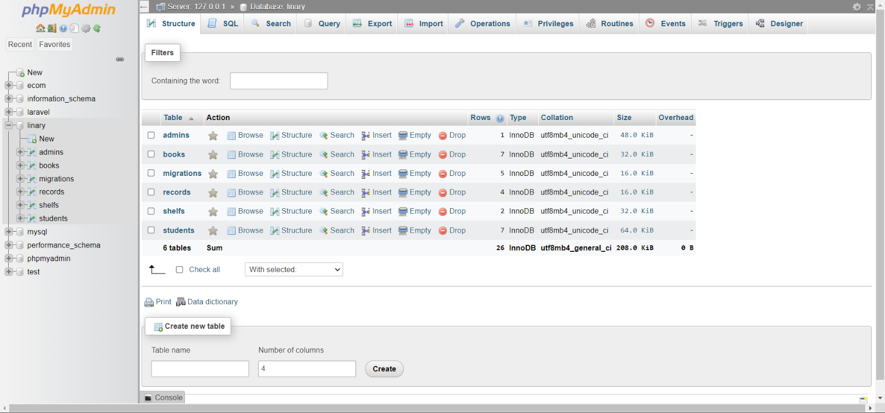

Testing phase

**METHODOLOGY USED FOR TESTING: -**

The methodology used for testing an online library management system includes white box testing (examining internal code and structures) and black box testing (evaluating functionality without knowledge of internal implementation) to ensure thorough testing of both internal and external aspects of the system.

We have basically used both of the above methods to test our software ->

|  |  |
| --- | --- |
| Test Case 1 | Unit Testing 1(Registration) |
| Tested By | Koulick Ghosh |
| Test Description | Users need to register by giving proper details |
| Input | Correct user name or Email & correct password |
| Status | Status Passed and registered |
| Input | Everything same but just taking same email which is already stored in database |
| Status | Not passed as it violates the validation of registering with unique email |
| Input | Proper Name, Unique Email but not giving same password in confirm password field |
| Status | Not passed as it violated the password validation |
| Input | Filling up everything properly and checking whether the password encryption works properly or not |
| Status | Passed as the password is getting stored in encrypted format |
| Test Case 2 | Unit Testing (User Login) |
| Tested By | Koulick Ghosh |
| Test Description | Users need to login with the same credentials given during registration |
| Input | Giving the username and password given during the registration process |
| Status | Passed |
| Input | Giving a username which is not registered |
| Status | Not Passed |
| Input | Giving a password which is not registered |
| Status | Not Passed |

|  |  |
| --- | --- |
| Test Case 3 | Unit Testing (Admin Login) |
| Tested By | Koulick Ghosh |
| Test Description | Admins entered wrong credentials for login |
| Input | Entering the wrong username and password for login |
| Status | Not Passed |
| Input | Entering right credentials which is registered |
| Status | Passed |

|  |  |
| --- | --- |
| Test Case 4 | OTP Verification |
| Tested By | Koulick Ghosh |
| Test Description | User need to enter correct OTP |
| Input | Entering correct OTP |
| Status | Passed |
| Input | User need to enter wrong OTP |
| Status | Passed |

|  |  |
| --- | --- |
| Test Case 5 | Changing User Password |
| Tested By | Koulick Ghosh |
| Test Description | User need to enter Old password, New Password & Confirm New Password |
| Input | User Enter wrong old pass & New Password |
| Status | Not Passed |
| Input | User need to enter wrong OTP |
| Status | Passed |

**USER MANUAL**

* 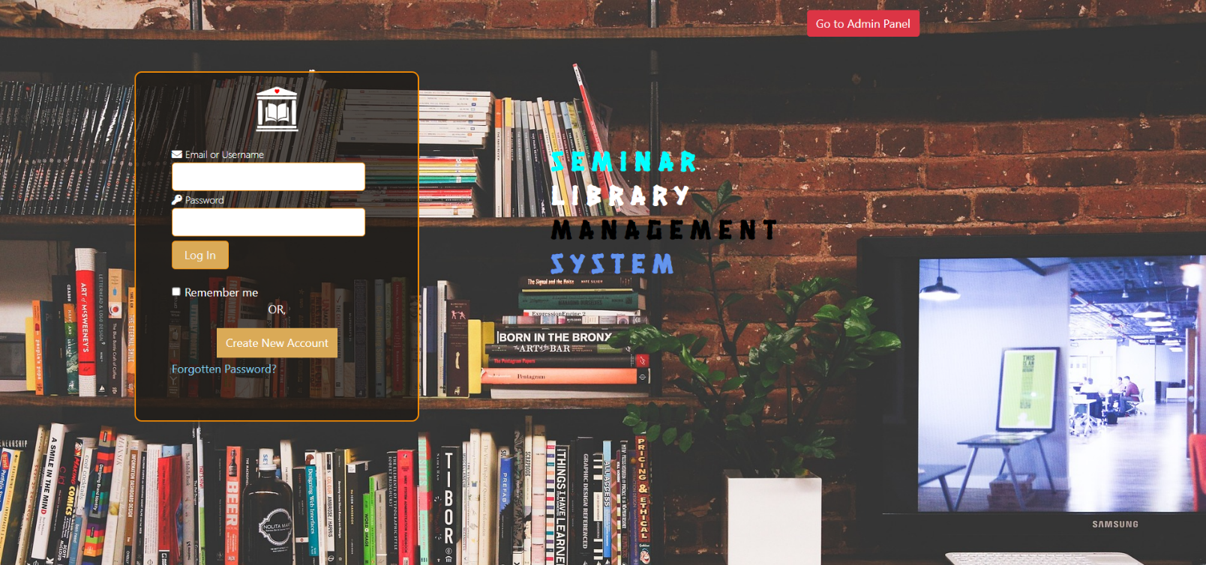**Home Page :-** The main or initial webpage of a website that provides an overview or gateway to the site's content.
* **User Registration: -** The process by which individuals create an account or profile on a website or platform to gain access to its features and services.

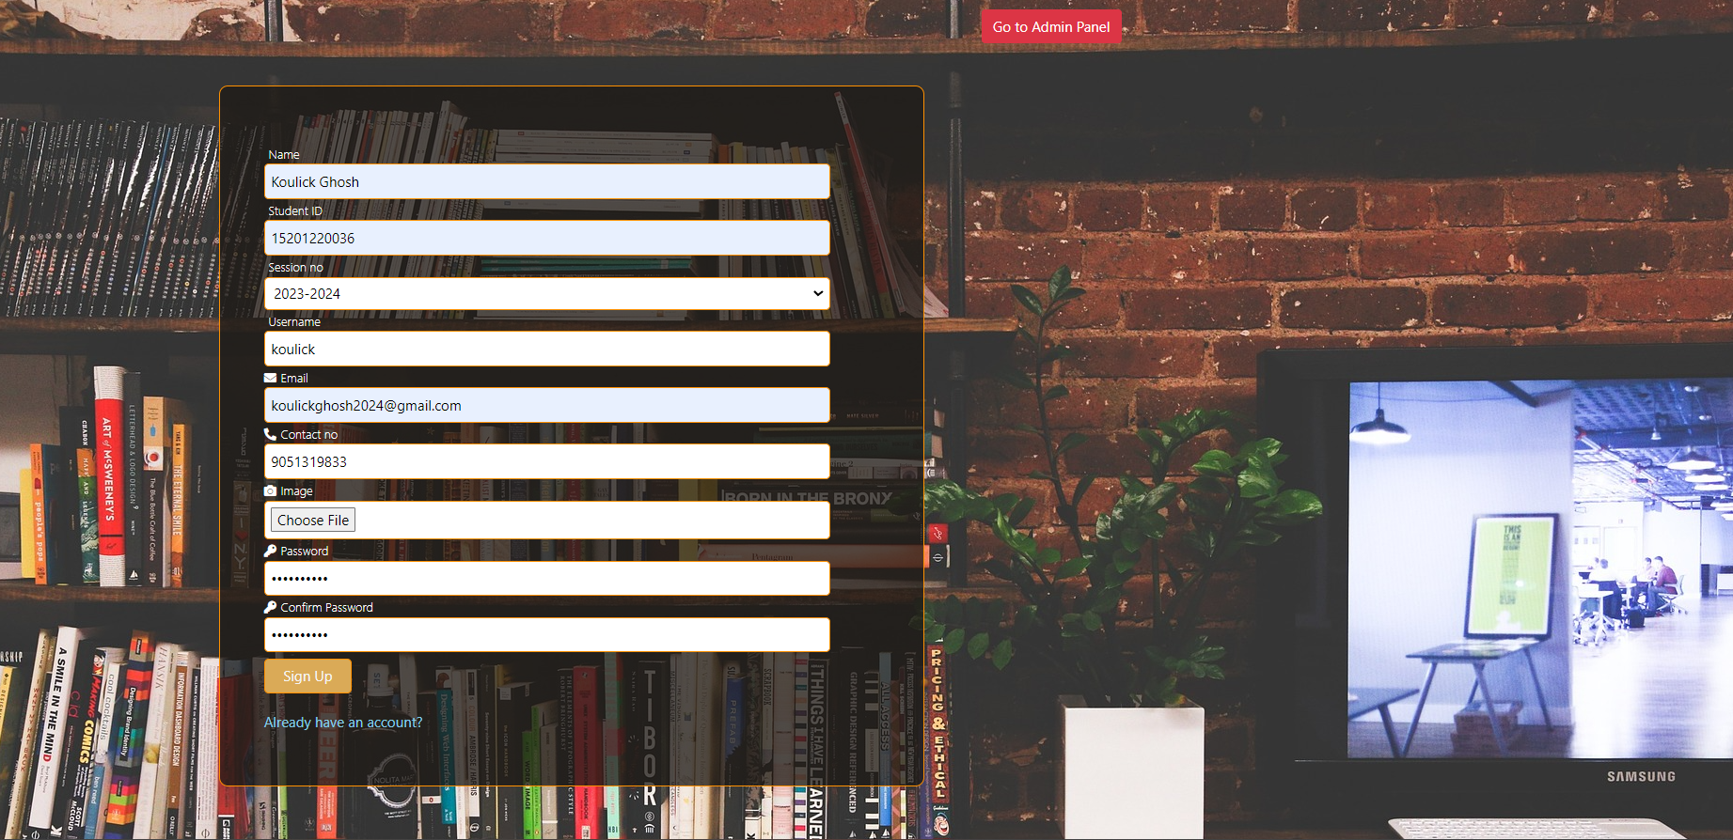

* **Email Verification Code :-**  A unique code sent to a user's email address during the registration or account verification process to confirm their ownership and validate their email.

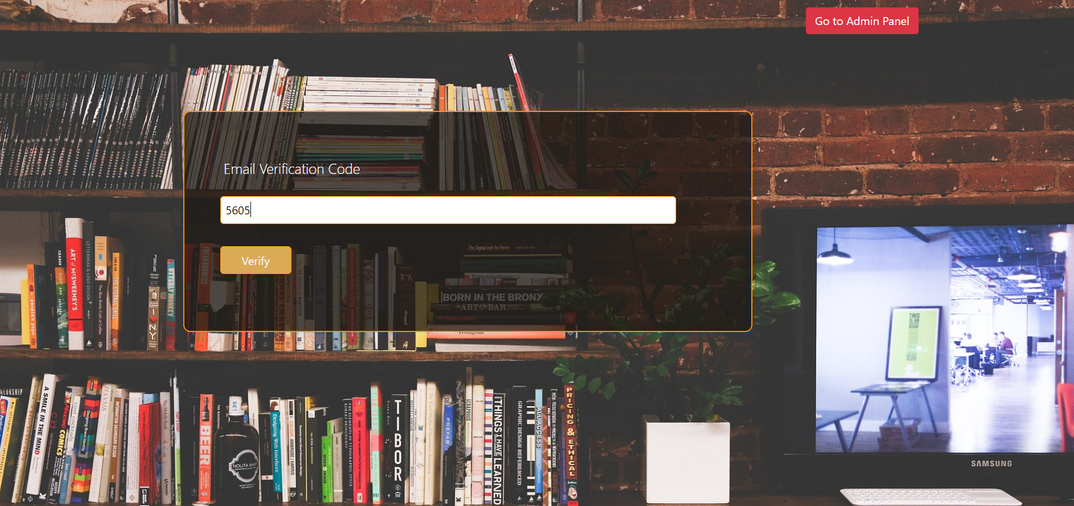

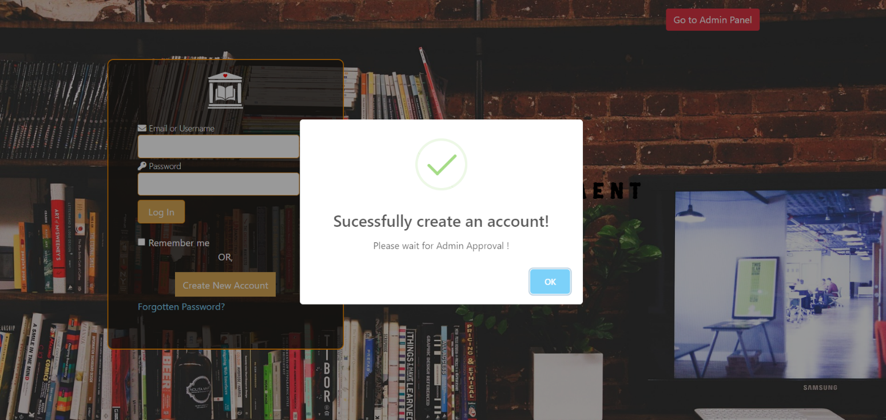 After that the User Successfully create an account!

* **Login The User :-** Login using user credential

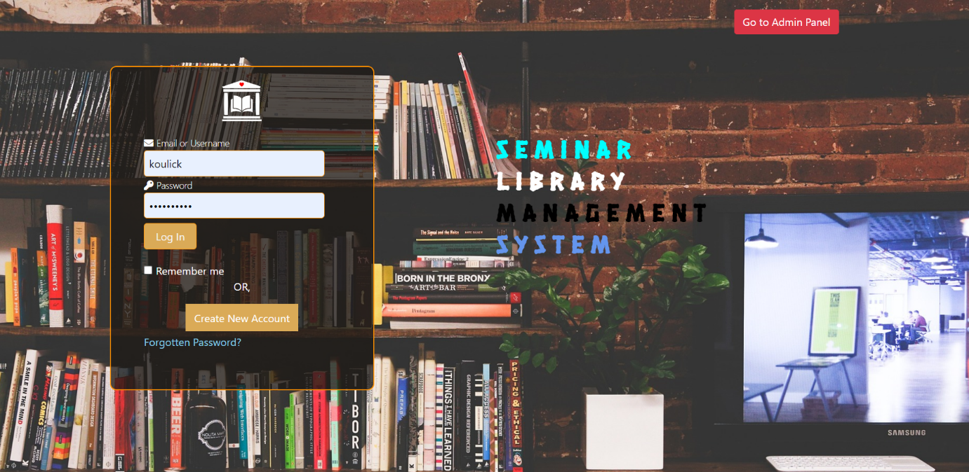

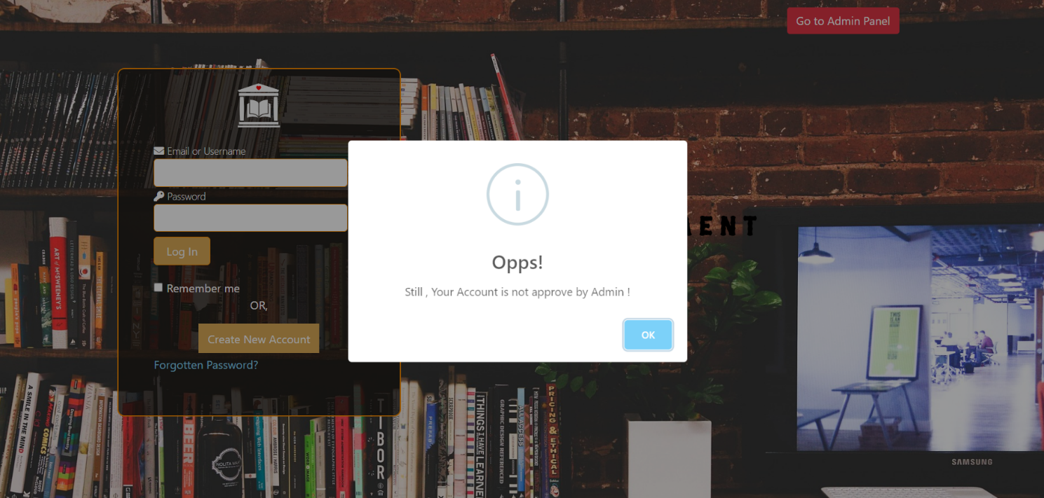After hitting login the pop will appear because admin/Liberian have to accept your registration request then you will login.

* **Verifying Registration Request :-** When a new student register his self the admin/Liberian have to verify the student.

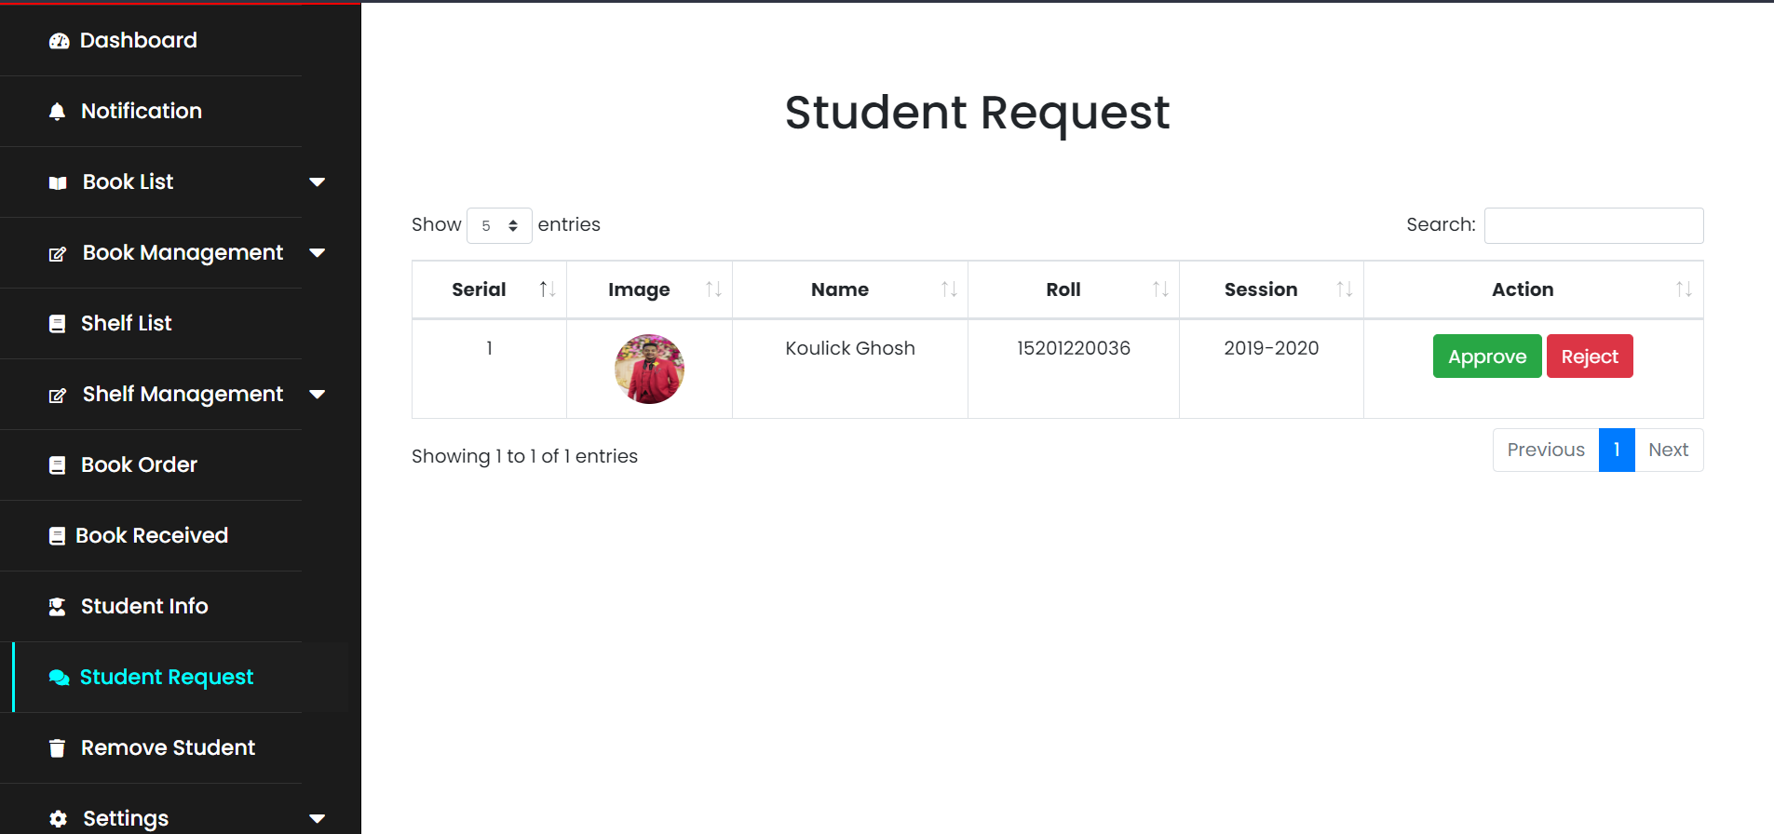

* 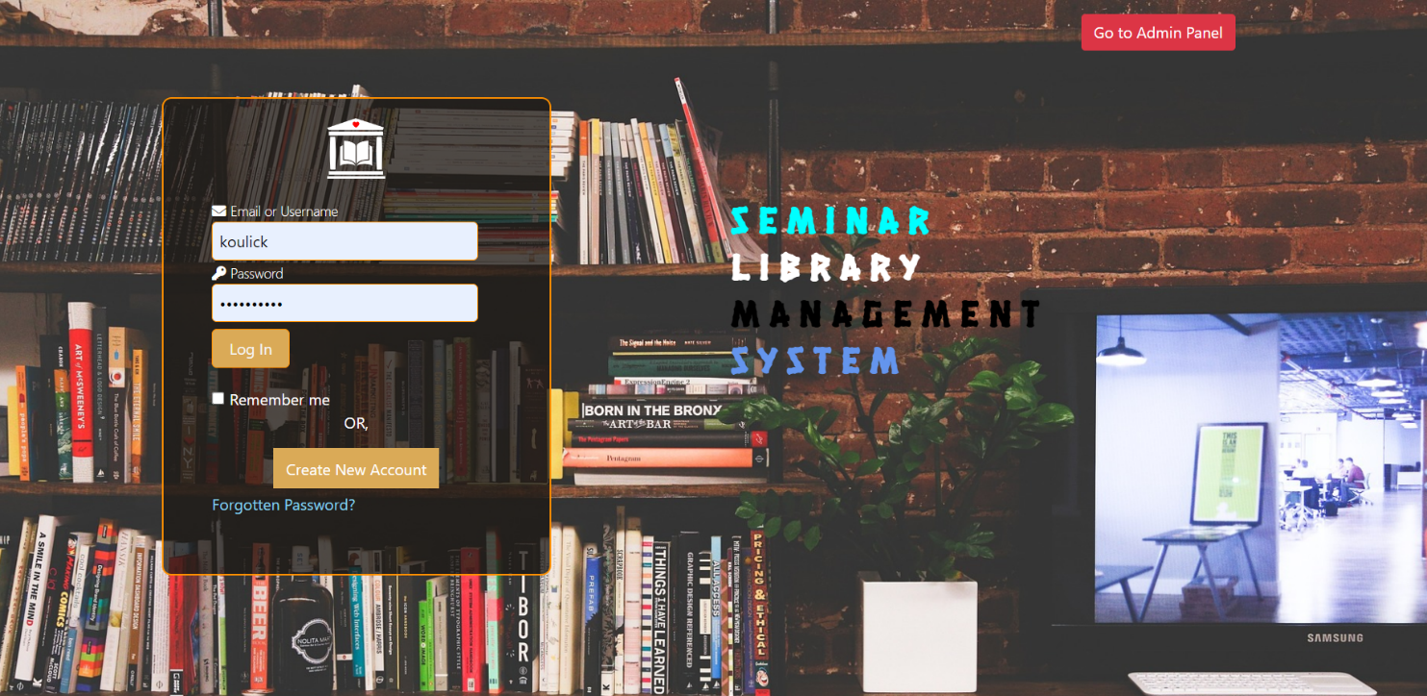**Login user :-** Login with user credential.
* 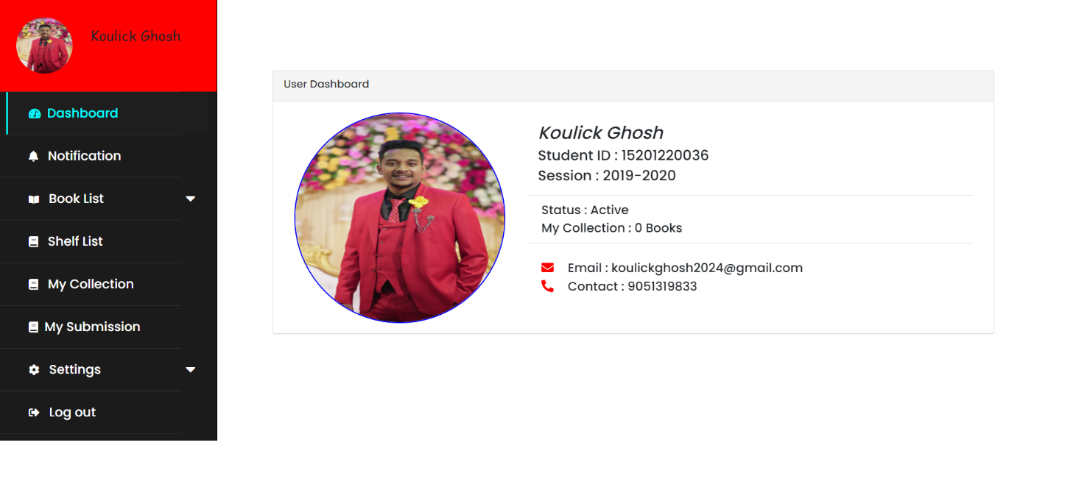**Student Dashboard :-** Here students can see his information.
* 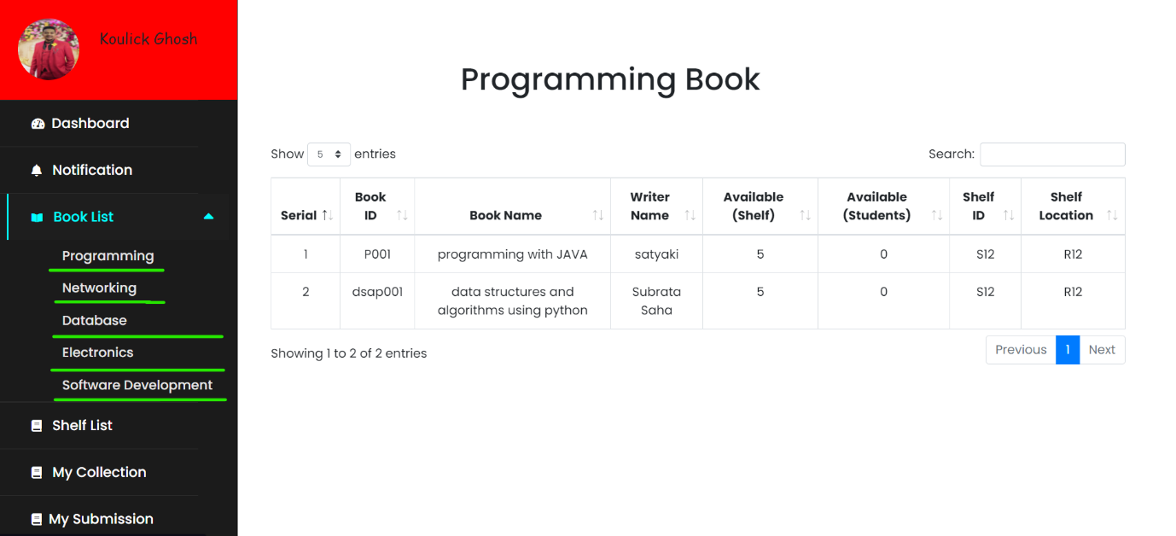**Book List :-** A compilation of books available in a library, containing details such as Book Id, Book Name, Writer Name, Shelf Id, Shelf Location, and availability for users.
* 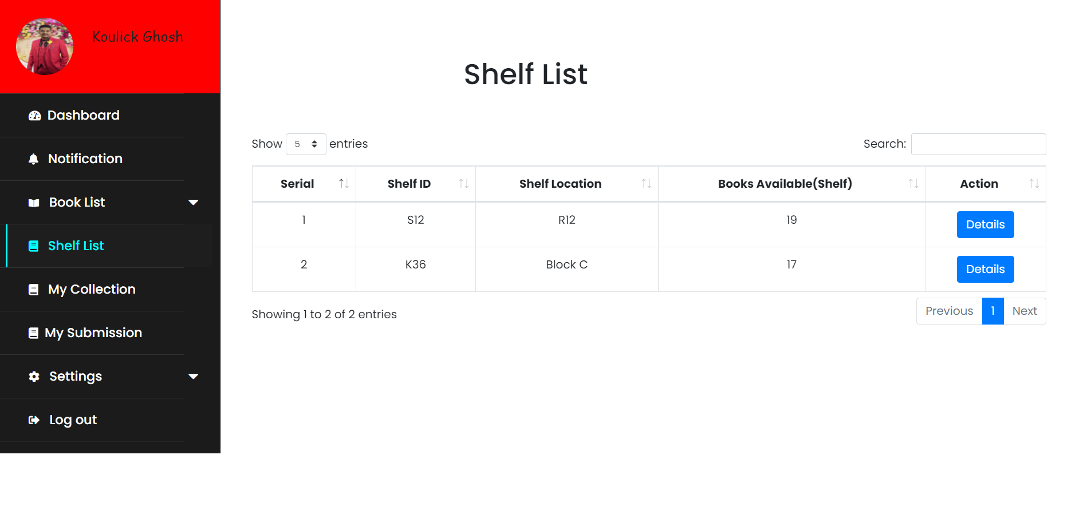**Shelf List :-** Here Students see shelf id, shelf location and book available on the shelf.
* 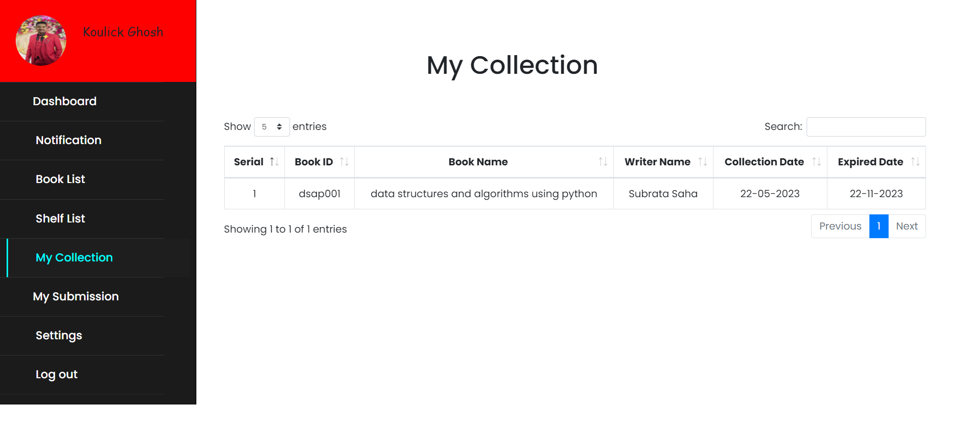**My Collection :-** A personalized compilation of books in a library management system, representing the specific titles that a user has selected or added to their personal collection for tracking or reference.
* **My Submission :-** The act of submitting or adding books to a library management system, where users provide details about books such as title, author, and other relevant information for inclusion in the system's database.

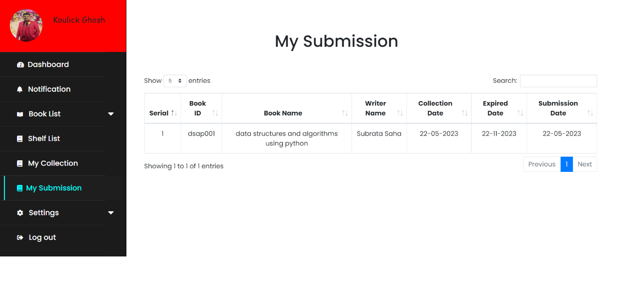

* 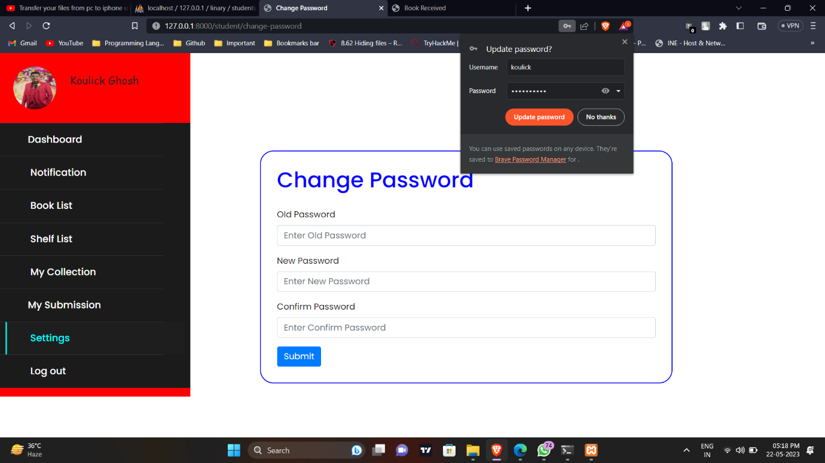**Change Password :-** User can change his password for security purpose.Now We will see Admin/ librarian perspective.

**Admin/Liberian**

* 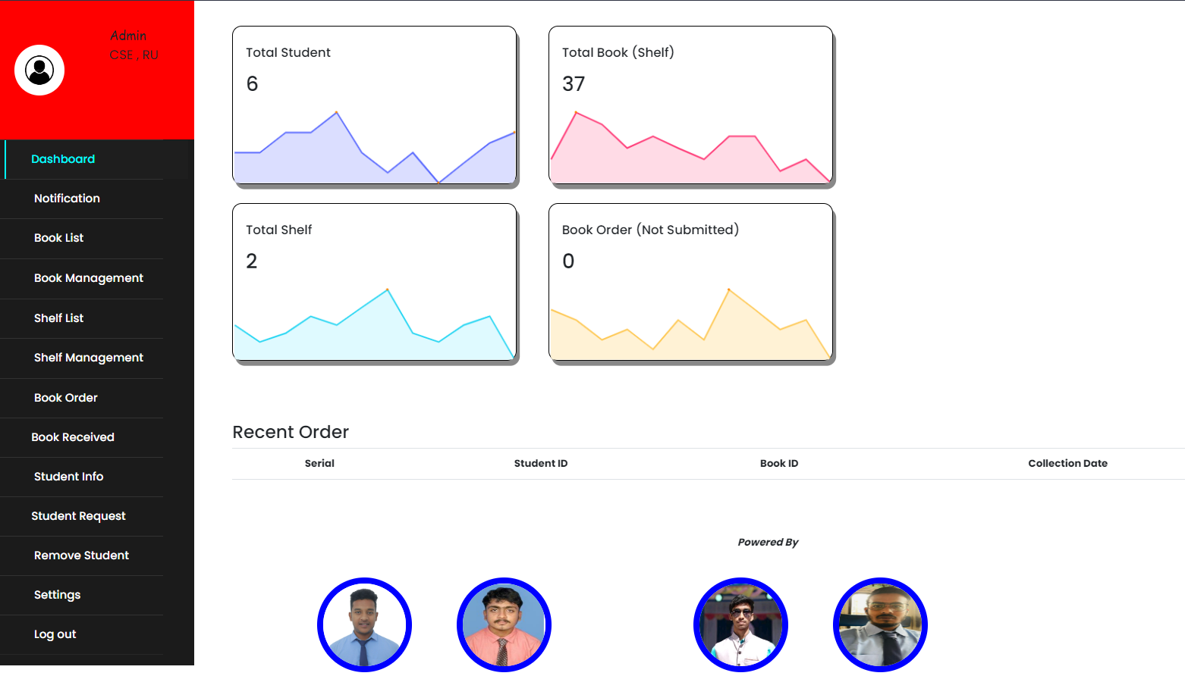**Admin/Liberian Dashboard :-** After login as Liberian first one dashboard. A Liberian what can do we will show in future.
* 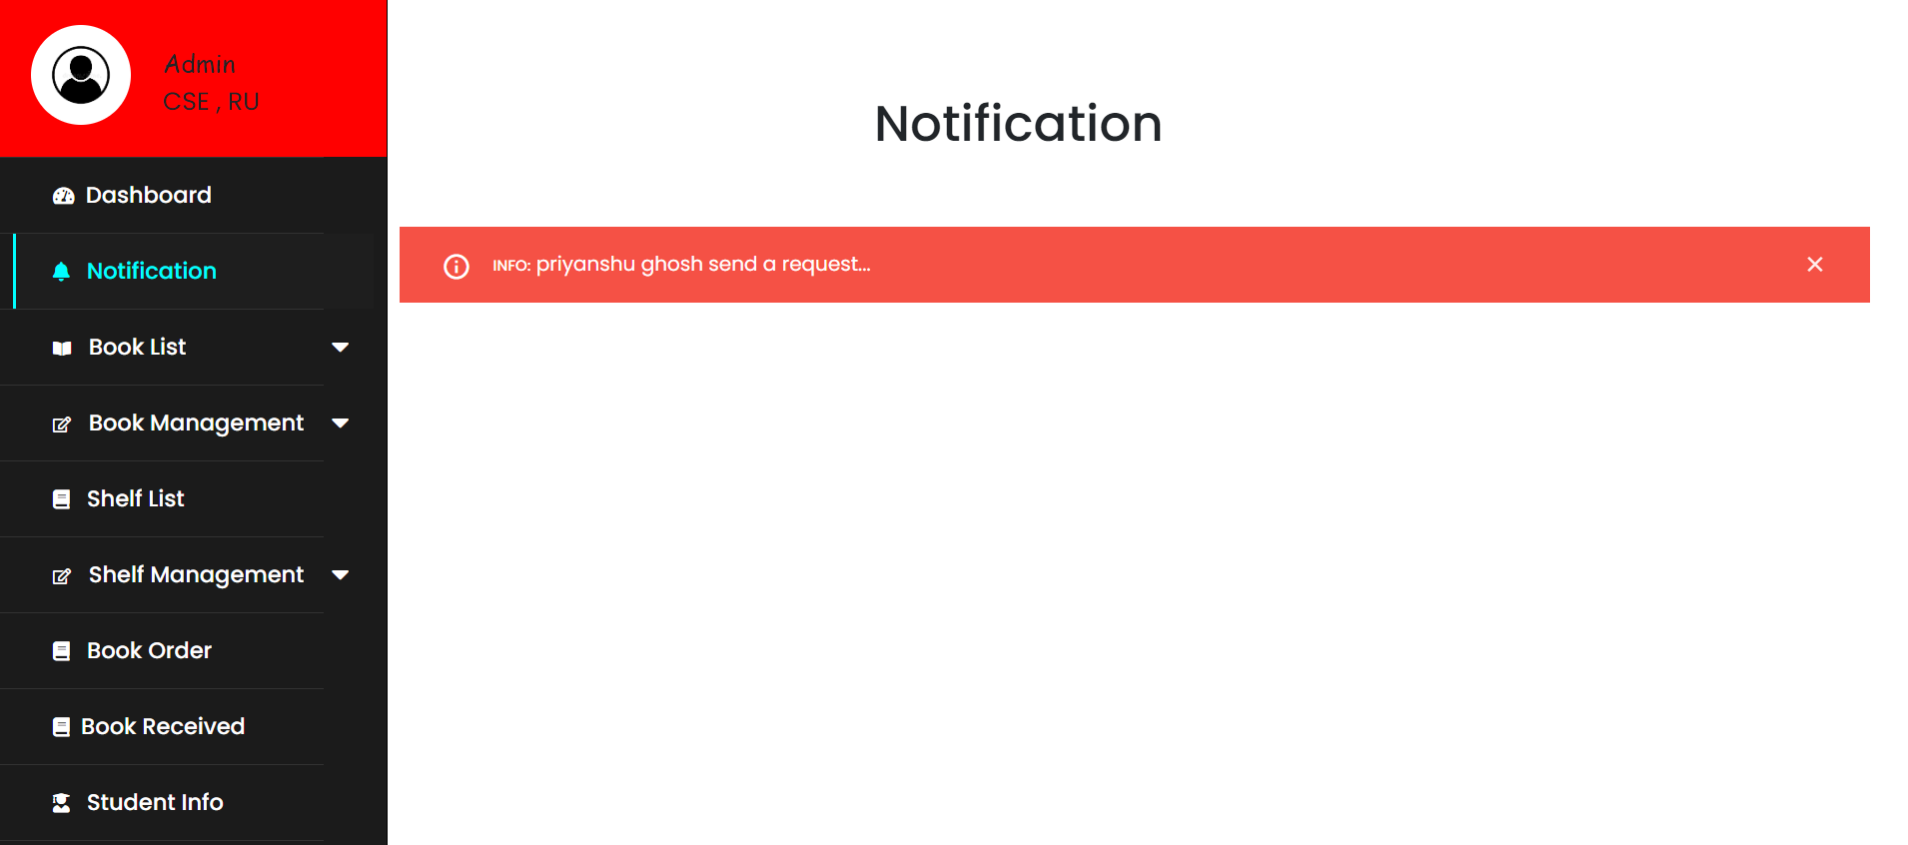**Notification :-** Liberian have notified when a new student register himself.
* 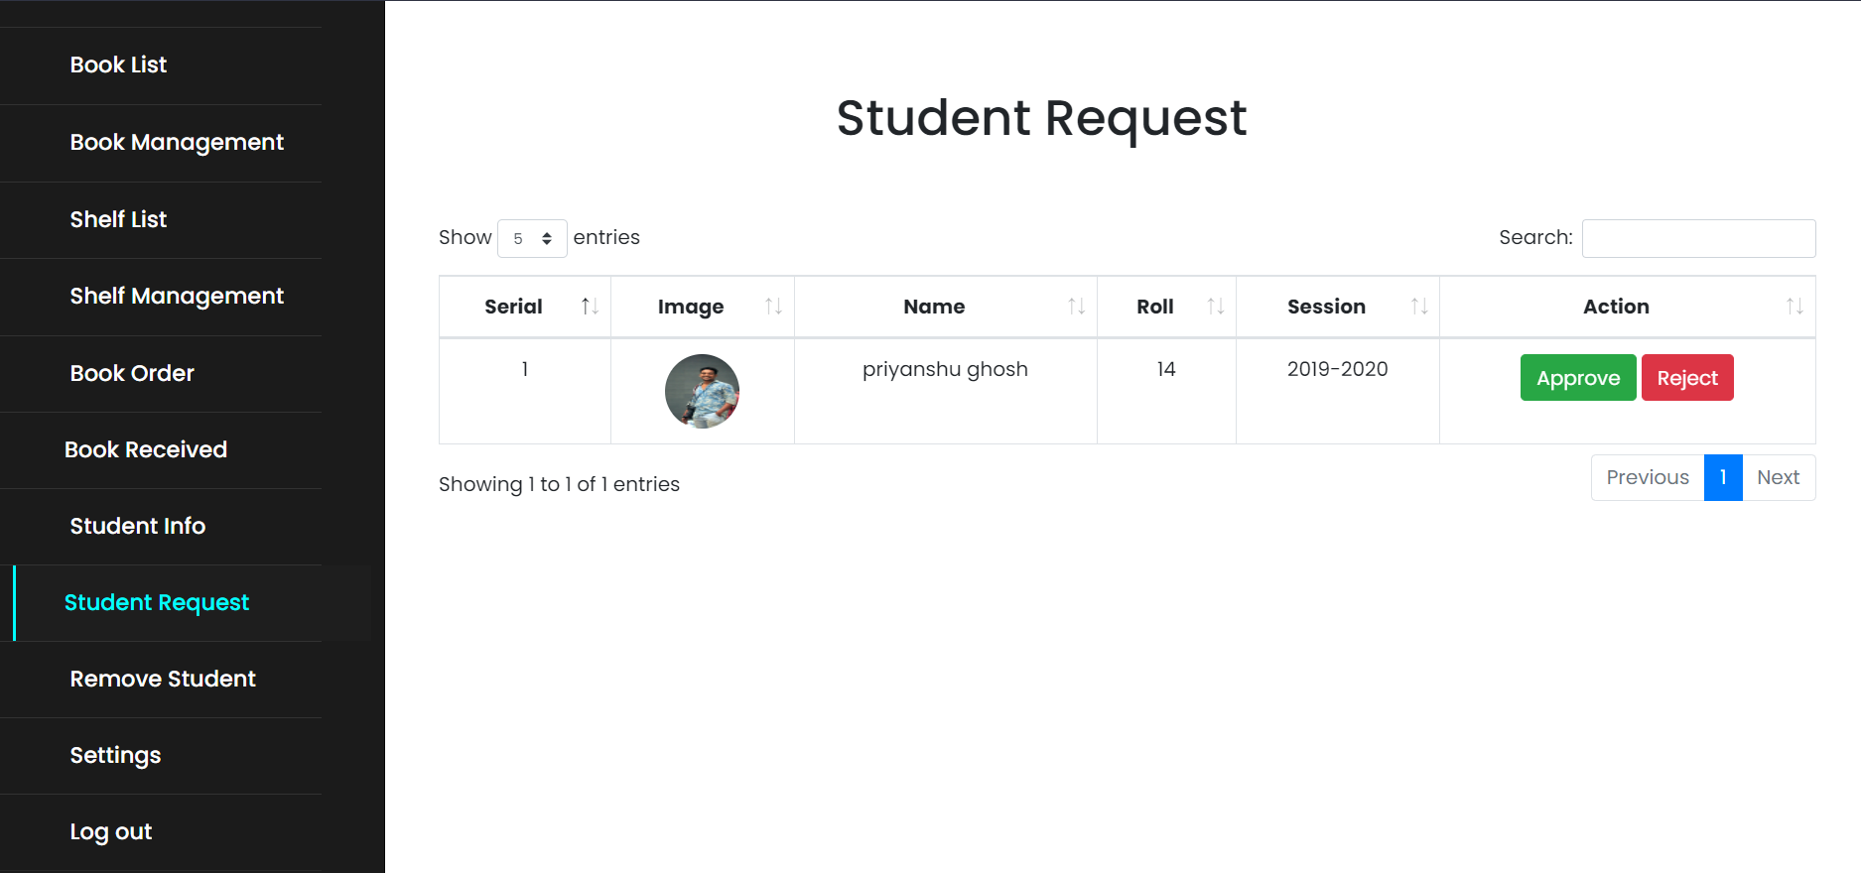**Student Request :-** When a new user/student register himself the admin/Liberian have to accept them. Then the student use the library.
* 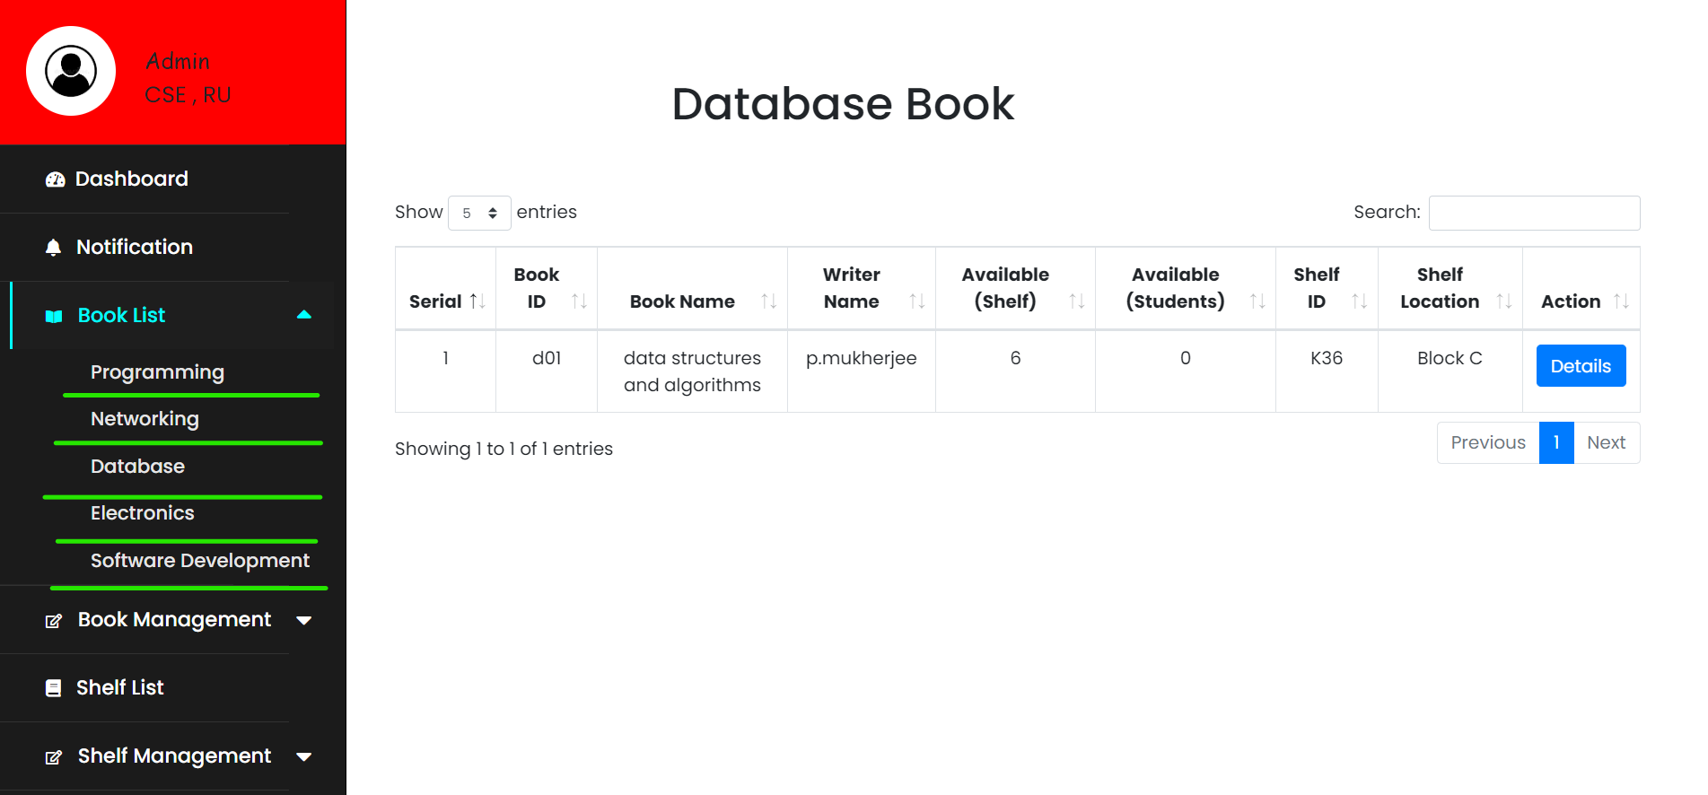**Book List :-** Admin can see all book list and their details.
* **Book Add :-** only Admin/Liberian can add new book in the list.

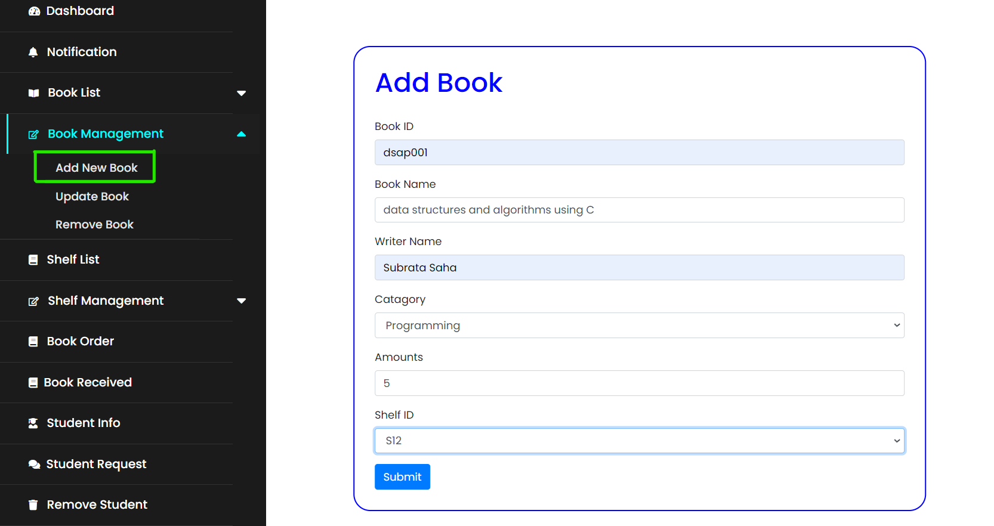

* 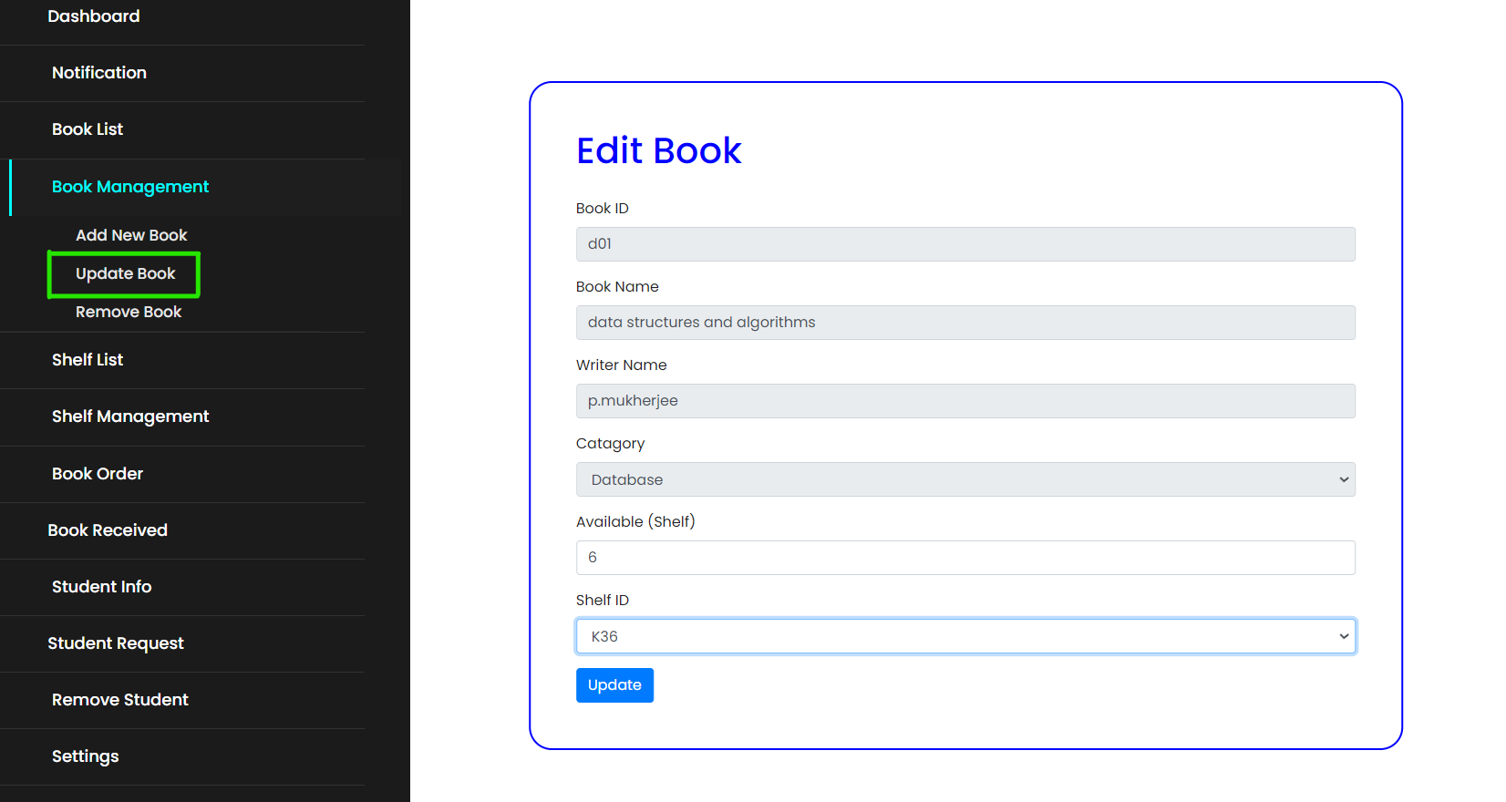**Edit Book :-** only Admin/Liberian can Update new book in the list.
* 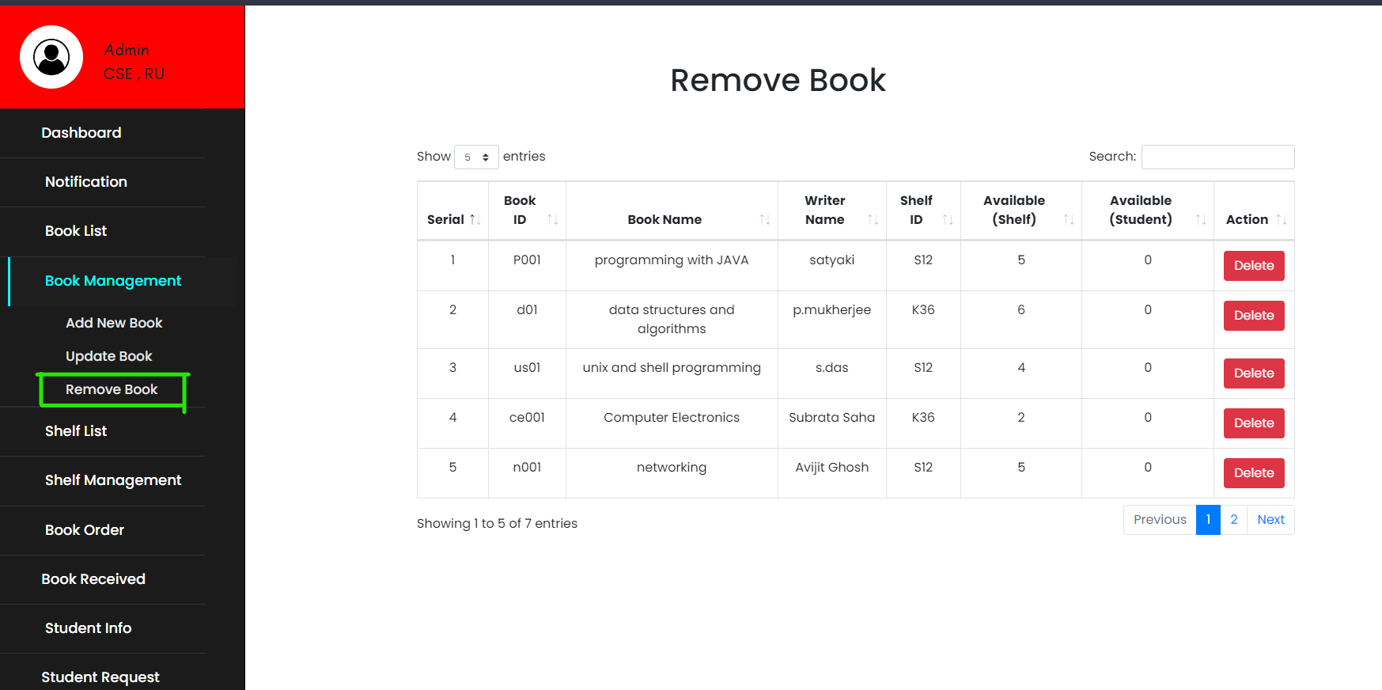**Remove Shelf :-** only Admin/Liberian can Remove new book in the list.
* **Shelf Id :-** only Admin/Liberian can see shelf-id or much more details.

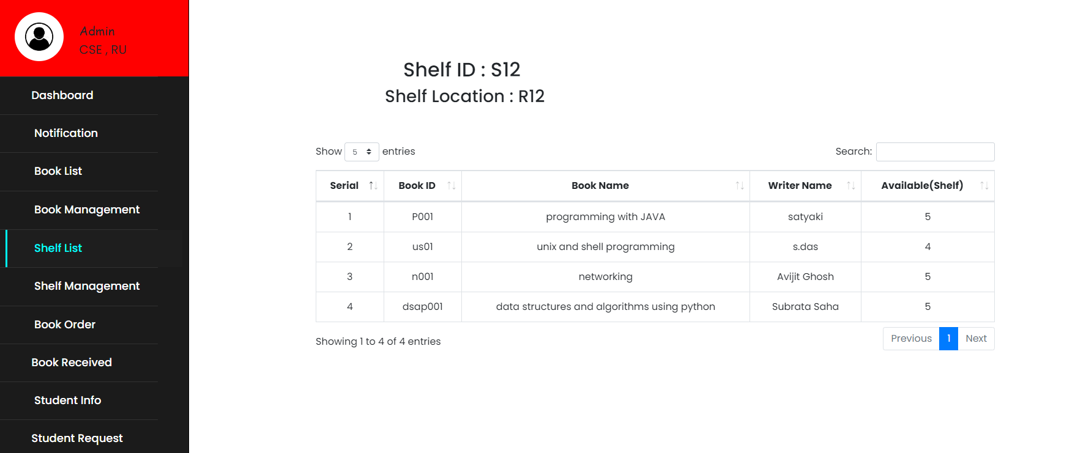

* 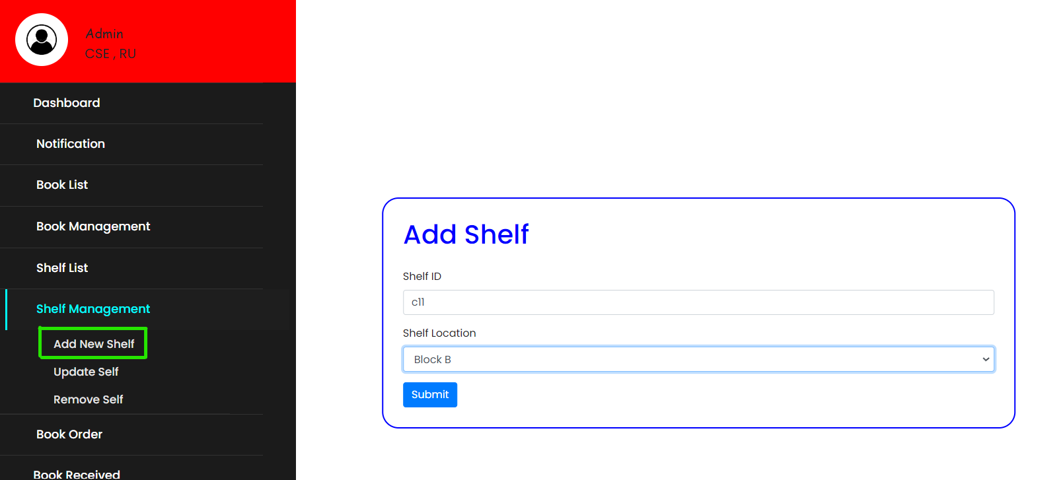**Shelf Management :-** only Admin/Liberian can add new shelf in the list.
* only Admin/Liberian can Update Shelf in the list.

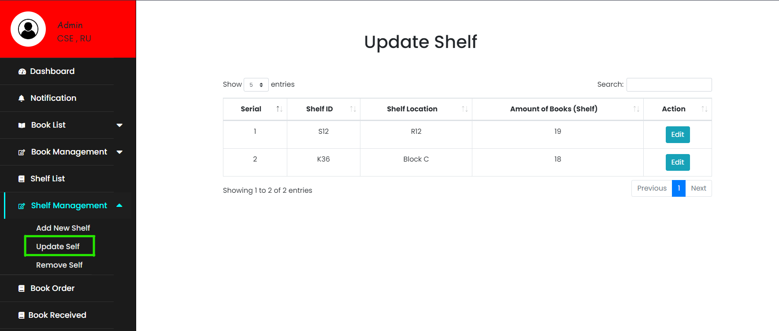

* 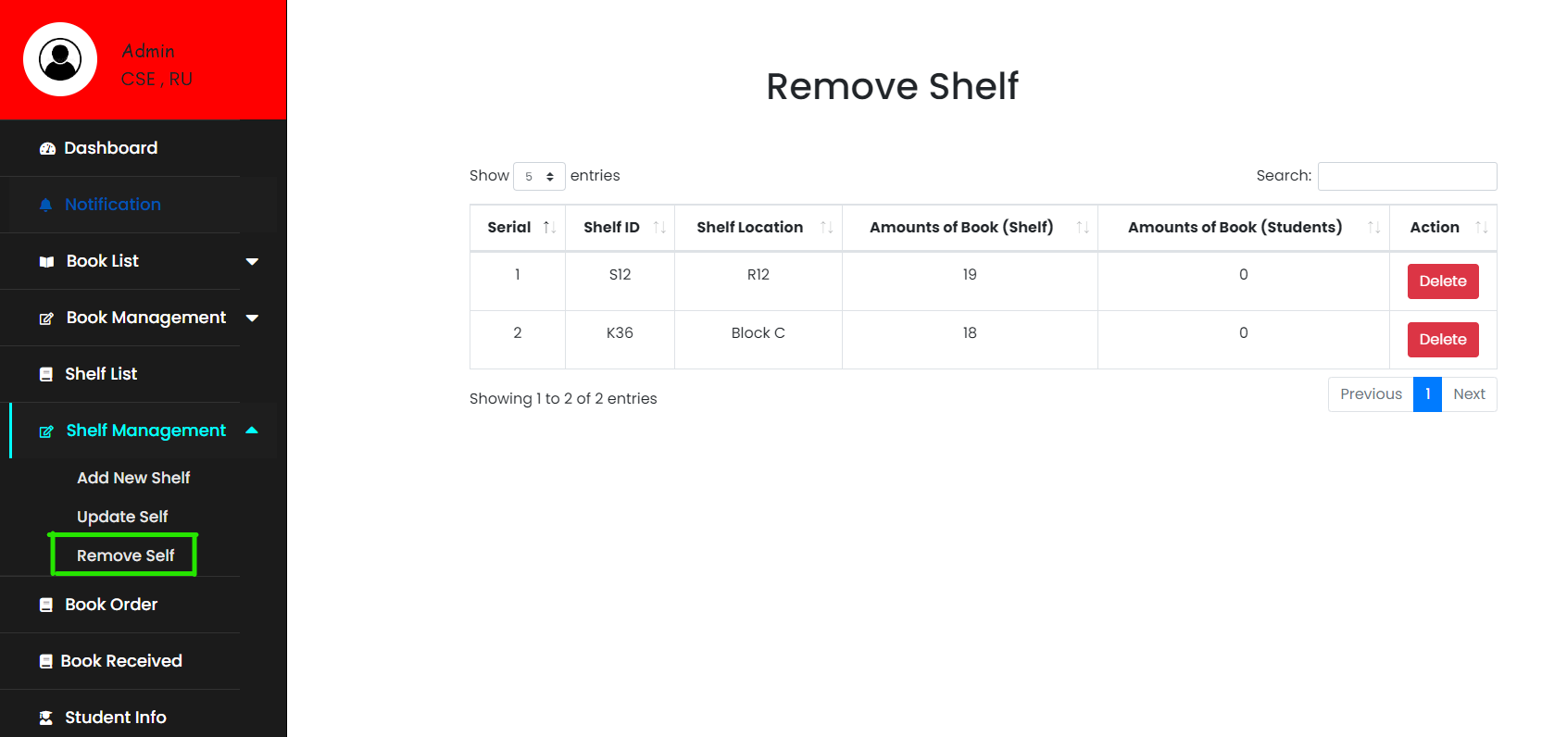only Admin/Liberian can Remove Shelf in the list.
* 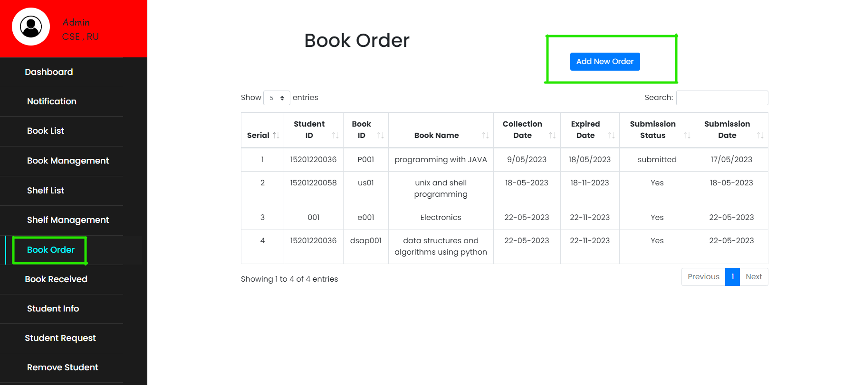**Book Order :-** only Admin/Liberian can make book order.
* 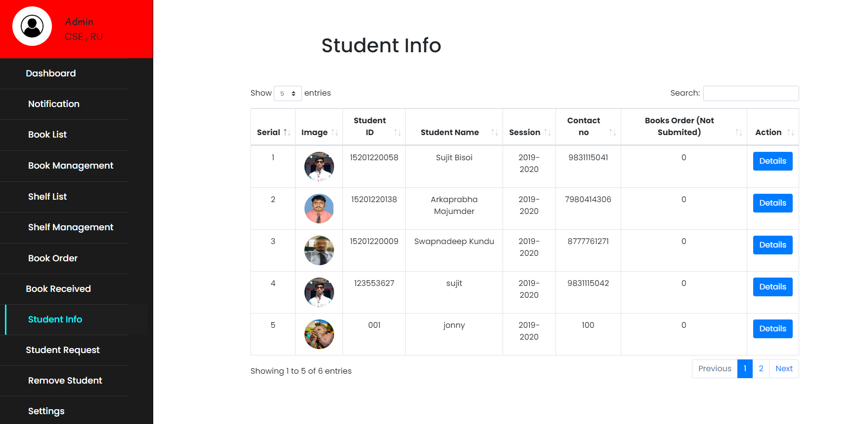**Students Info :-** only Admin/Liberian can see details of the students.
* **Remove Students :-** only Admin/Liberian can remove students.

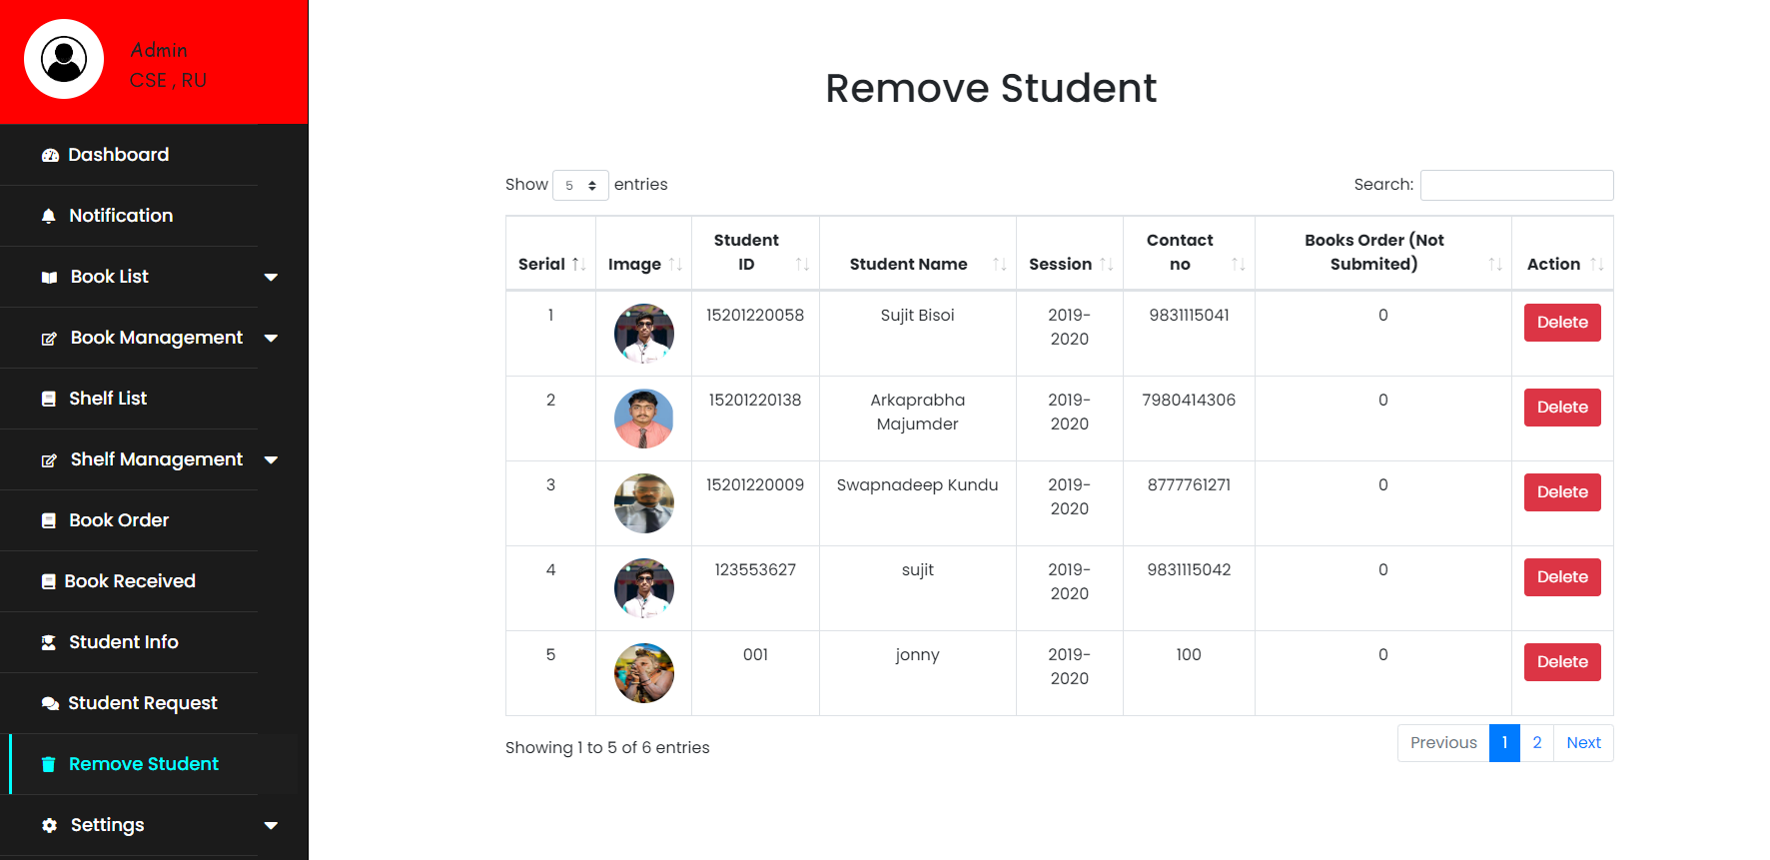

* 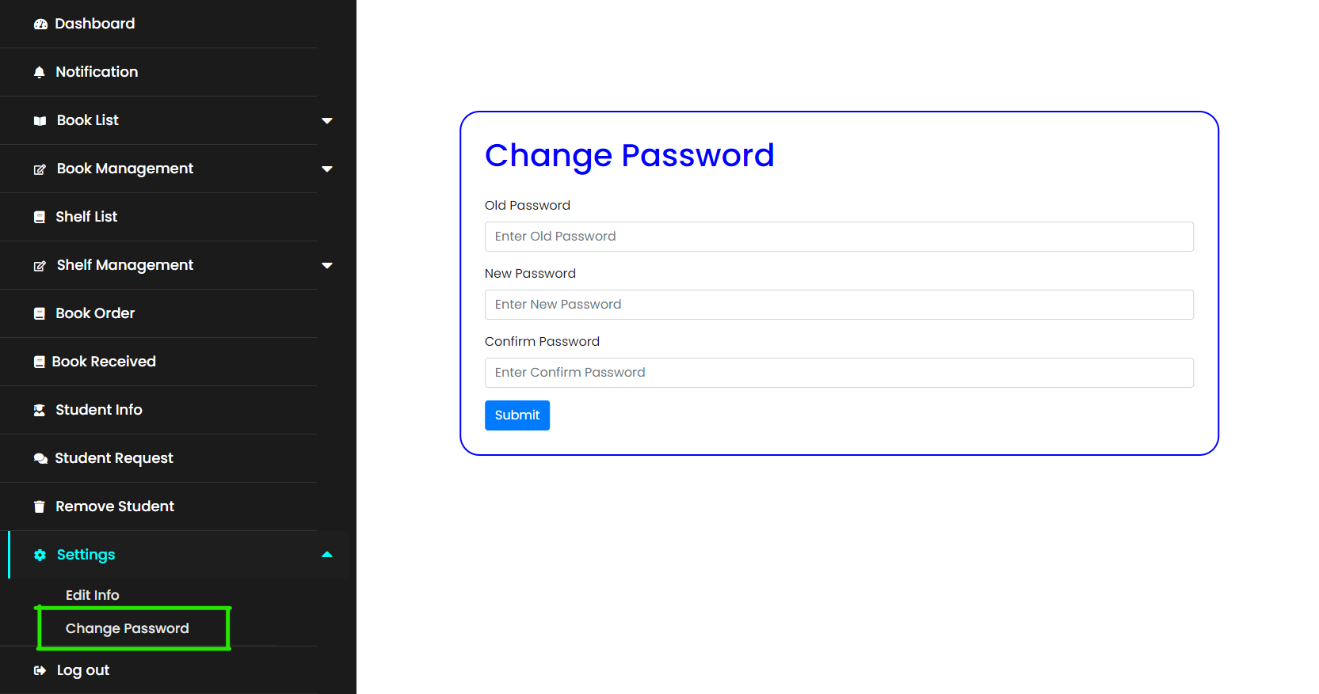**Changing Password :-** Admin/Liberian can change his password for security purpose.

Conclusion

**Limitation :-**

1. Initial setup and implementation can be time-consuming and require technical expertise.

2. Cost implications may arise from purchasing the software, hardware, and ongoing maintenance and support.

3. Customization options may be limited, preventing libraries from tailoring the system to their specific needs.

4. Integration with other systems, such as interlibrary loan networks or digital repositories, may be challenging or require additional development.

5. User training and adoption may pose challenges, particularly for staff members who are less comfortable with technology.

**Future Planning :-**

1. Integration with emerging technologies: Explore integrating the system with emerging technologies like artificial intelligence, machine learning, or data analytics to enhance user experience, automate processes, and provide personalized recommendations.

2. Mobile and web accessibility: Develop mobile applications and web interfaces to ensure seamless access to library resources and services across different devices, catering to the evolving needs and preferences of users.

3. Enhanced collaboration and resource sharing: Focus on strengthening interlibrary collaborations and resource sharing networks by implementing protocols and standards that facilitate seamless resource sharing and cooperative collection development.

4. User-centric features: Continuously improve the user experience by incorporating features like personalized profiles, advanced search capabilities, virtual browsing, and interactive interfaces to engage and serve users better.

Bibliography

This project has been successfully completed just because of the utmost support from the professors, mental and emotional support of our parents, the dedicated efforts of each and every of this group and by the Almighty’s blessings. We believe that our dream project can make our teachers and our project guide happy and feel proud of us.

<http://www.slideshare.net/>

<http://www.geeksforgeeks.org/>

<http://www.geeksforgeeks.org/>

<http://www.javatpoint.com/>

Thanking you